**Funding and Communication Plan for Integrační Centrum Praha**  
 

Report Prepared By:

Andres Casanova-Aleman  
Alba Muñoz Henriquez  
Briget Simeoni  
David Strom

**Funding and Communication Plan for Integrační Centrum Praha**

An Interactive Qualifying Project

submitted to the faculty of

WORCESTER POLYTECHNIC INSTITUTE

in a partial fulfillment of the requirements for the

degree of Bachelor of Science

By:

Andres Casanova-Aleman

Alba Muñoz Henriquez

Briget Simeoni

David Strom

Date:

December 14, 2024

Report Submitted to:

Professor Michael Ginzberg

Professor Beth Eddy

Worcester Polytechnic Institute

This report represents the work of WPI undergraduate students submitted to the faculty as evidence of a degree requirement. WPI routinely publishes these reports on its web site without editorial or peer review. For more information about the projects program at WPI, see <http://www.wpi.edu/Academics/Projects>.

**Abstract**

Integrační Centrum Praha (ICP) is a non-governmental organization that helps integrate migrants into the Czech Republic. The team initially worked with ICP to discover methods to improve its current operations. As the project developed, the goal was changed to find less restrictive funding strategies and improve its communication strategy. The team achieved this by researching alternative funding sources, interviews, and an analysis of different media platforms. These findings helped form a new funding and communication strategies plan for ICP.

# Executive Summary

Several non-governmental organizations (NGOs) exist around the world who tackle the socio-economic issue of immigration and share the mission of integrating migrants into their respective country’s society. To pursue this said mission, these organizations often turn to local and international funds; however, these funds are often tied to several restrictions (Bromley et al., 2020).

As a result, the goal of this project was to find less restrictive funding strategies for Integrační Centrum Praha to ensure the organization's ability to improve its operations in the Czech Republic. To ensure the recommended sources of funding are most effective, ICP must simultaneously improve their communication to their various constituencies. The team accomplished this goal through the following objectives: research alternative sources of funding that are less restrictive and understand ICP’s current communication strategies and compare it to other NGOs’ strategies in the Czech Republic.

By conducting thorough research on several sources of funding, the team found three less-restrictive avenues for ICP to approach: the private sector, crowdfunding, and the general public. These findings allowed the team to compose a new funding strategy plan. For funding within the private sector, ICP should approach private institutions/funds and corporate partnerships. On the other hand, ICP should also consider different crowdfunding alternatives within the Czech Republic – specifically, Darujme.cz and WhyDonate. Lastly, ICP does not currently have a donate button on their website. As a result, adding a donor button could enable visitors to easily make donations and establish an individual donor base. The utilization of these three avenues would result in less restrictive sources of funding, and combined, would enable ICP to make several organizational improvements.

ICP also struggles to reach a large audience through their media platforms which can inhibit the success of the recommended funding strategies. Through qualitative structured interviews and media analysis, the team also identified improvements to ICP’s current communication strategies and composed a new communication strategies plan. An interview with ICP’s head of the public relations (PR) department revealed that the organization currently struggles to reach its primary audience – the migrants they work with – but does in fact reach its secondary audience – the Czech population – across all media platforms. On the other hand, an analysis of other Czech NGO’s strategies revealed several improvements that ICP could implement to their own media strategies. These efforts combined provided many useful insights that ICP could make use of to improve their media presence.

Integrační Centrum Praha is a non-governmental organization that successfully helps integrate thousands of migrants into the Czech Republic. The team composed the mentioned funding and communication strategies plan with the hopes of providing relative and appropriate recommendations to the organization. By using these plans, ICP could reap the benefits of less restrictive sources of funding and maximize those said benefits with improved communication strategies.

# Acknowledgements

The team would like to thank the project’s sponsor, Integrační Centrum Praha (ICP) - the success of this project would not have been possible without the help of several individuals. To begin with, the team would like to thank Josef Petr, the strategic development manager, for dedicating his time and efforts to meeting with the team weekly and helping the project take shape. The team would also like to thank Anca Covrigová, the initial project expert, for providing the team with the guidelines necessary to complete this project. Lastly, the team would like to thank Michaela Palánová, the head of the public relations department, whose support helped form a better understanding of the organization’s current strategies. On the other hand, the team would also like to thank the project’s advisors, Professor Michael Ginzberg and Professor Beth Eddy, who participated actively in ensuring this project’s success since its inception.

# Authorship Page

|  |  |  |
| --- | --- | --- |
| **Section** | **Primary Author(s)** | **Primary Editor(s)** |
| Abstract | ACA | AMH |
| Executive Summary | ACA | AMH |
| Acknowledgements | ACA | DS, AMH, BS |
| Meet the Team | (All) | (All) |
| 1.0 Introduction | (All) | (All) |
| 2.0 Background | DS | ACA |
| 2.1 Europe and Immigration Trends | DS | AMH, BS |
| 2.2 Interplay of Popular Opinion and Economic Impact | ACA, AMH | DS, BS |
| 2.3 Integrační Centrum Praha (ICP) | ACA | AMH |
| 2.4 Sources of Funding | DS, BS | ACA, AMH |
| 2.5 Communication Strategies | AMH, BS | ACA, DS |
| 2.6 Summary | ACA | DS |
| 3.0 Methodology | ACA | AMH |
| 3.1 Identify Alternative Sources of Funding | DS, BS | ACA, DS |
| 3.2 Improving Current Communication Strategies | ACA, AMH | AMH, DS |
| 4.0 Results | ACA | AMH |
| 4.1 Funding Strategies for ICP | DS, BS | ACA, AMH |
| 4.2 Communication Strategies for ICP | ACA, AMH | DS, BS |
| 5.0 Deliverables | (All) | (All) |
| 6.0 Conclusions | DS | (All) |
| 6.1 Ethical Considerations | DS | ACA, BS |
| 6.2 Limitations | BS, DS | DS |
| 6.3 Final Reflections | ACA | AMH, DS |
| Bibliography | (All) | (All) |
| Appendices | ACA, DS | AMH, BS |
| Supplemental Materials | (All) | (All) |

**Meet the Team**

|  |  |
| --- | --- |
|  | **David Strom (DS)**  I am a Junior Mechanical Engineering student from Marion, Massachusetts. |
|  | **Alba Muñoz Henriquez (AMH)**  I am a Junior Aerospace Engineering student from the Canary Islands, Spain. |
|  | **Andres Casanova-Aleman (ACA)** I am a Junior Mechanical Engineering student from Madrid, Spain. |
|  | **Briget Simeoni (BS)**  I am a Junior Biology and Psychology major on the pre-medical track with a biochemistry minor from Corsica, France. |

# Table of Contents

Abstract………………………………………………….…………………………........................i Executive Summary....…………………………………………….…………………………........ii Acknowledgements.……………………………………………….…………………………......iii Authorship Page………………………………………………….………………………….........v

Meet the Team...............................................................................................................................vi

List of Figures...................…………………………………………………...…………….........viii 1.0 Introduction……………………………………………………...………................................1 2.0 Background.……………………………………………………...………...............................3 2.1 Europe and Immigration Trends....................................................................................3

2.2 Interplay of Popular Opinion and Economic Impact....................................................5

2.3 Integrační Centrum Praha (ICP)...................................................................................7

2.4 Sources of Funding...........…………………………………………..………...……...8

2.5 Communication Strategies...…………………………………...………....................13

2.6 Summary.....................................................................................................................15

3.0 Methodology.……………………………………………………...………...........................16

4.0 Results........………………………………………………...………......................................24

4.1 Funding Strategies for ICP..........................................................................................24

4.1.1 Within Private Sector...................................................................................24

4.1.2 Within Crowdfunding..................................................................................28

4.1.3 Within General Public..................................................................................31

4.2 Communication Strategies for ICP.............................................................................37

4.2.1 How ICP Communicates with the Public....................................................37

4.2.2 How Other NGOs Communicate with the Public........................................40

5.0 Deliverables …………………………………………….......................................................46

6.0 Conclusion.……………………………………………………...………..............................48 Bibliography.................................................................................................................................48Appendices...................................................................................................................................48

Supplemental Materials................................................................................................................49

# List of Figures

Figure 2.1: Net Migration in the Czech Republic……………….…………………………..........4

Figure 2.2: Prague Inhabitants Feel Negatively About Ukranian Refugees...………….…...........6

Figure 2.3.1: Website Navigation Bar for Organizace Pro Pomooc Uprchlikûm....….…....…...12

Figure 2.3.2: Website Navigation Bar for InBáze………………………...………….................12

Figure 4.1.1: Darjume.cz Front Page............................................................................................29

Figure 4.1.2: Why Donate Front Page..........................................................................................30

Figure 4.1.3: Organizace Pro Pomoc Uprchlíkům Donate Button...............................................33

Figure 4.1.4: Kroky Dobra Donate Button...................................................................................33

Figure 4.1.5: Centrum Locika Donation Page..............................................................................34

Figure 4.1.6: Centrum Locika Imagery Use.................................................................................35

Figure 4.1.7: ADRA.cz Main Page...............................................................................................36

Figure 4.2.1: Integrační Centrum Praha’s Social Media Follower Demographics.......................39

Figure 4.2.2.1: META’s Facebook Engagement and Posts Published Over Time.......................41

Figure 4.2.2.2: OPU’s Facebook Engagement and Posts Published Over Time..........................41

Figure 4.2.2.3: InBaze’s Facebook Engagement and Posts Published Over Time.......................42

Figure 4.2.2.4: Centrum Locika’s Facebook Engagement and Posts Published Over Time........43

Figure 4.2.2.5: Loono’s Facebook Engagement and Posts Published Over Time........................43

Figure 4.2.2.6: Asistence’s Facebook Engagement and Posts Published Over Time...................44

# 1.0 Introduction

Immigration is a socio-economic issue that impacts individuals in all countries, with around 281 million international migrants in the world in 2020 (McAuliffe et al., 2024). To integrate migrants, governments work closely with non-governmental organizations (NGOs) that aid migrants with navigating life in a new country. Since the start of the Russo-Ukrainian War in 2022, the European Union (EU) is experiencing an unforeseen increase in immigration, with around 6 million refugees registered across EU countries as of July of 2024 (UNHCR, 2024). In particular, the Czech Republic granted temporary protection status to over 530,000 Ukrainians and is the third highest accepting country of Ukrainian refugees as of June 2023 (UNHCR, n.d.). Consequently, the country’s reliance on NGOs is increasing, and there is a heightened demand for their services.

This increase in demand for their services is one shared by several non-governmental organizations around the world, and as a result, they suffer due to not having the necessary resources (McRay, 2024). Shifts in politics and public opinion can affect NGO-donor relationships while fluctuations in economic conditions can result in changes in the availability of funding for NGOs (McRay, 2024). Together, these factors lead to financial instability for non-governmental organizations and hinder their ability to pursue their missions. As a result, these organizations must diversify their sources of funding.

One non-governmental organization that helps tackle the influx of migrants in the Czech Republic is Integrační Centrum Praha (ICP), located in the city of Prague. Although the organization is receiving funding from the Asylum Migration Integration Fund (AMIF), these funds may only be used to provide the most essential services, and consequently they struggle to support all the activities required to fulfill and expand their mission (Asylum, Migration and Integration Fund, 2023). As a result, the organization, like other NGOs around the world that deal with immigration, lacks the time needed to explore new and non-restrictive sources of funding and is limited in its ability to make improvements to its communication strategies.

The goal of this project was to find less restrictive funding strategies for Integrační Centrum Praha to ensure the organization's ability to improve its operations in the Czech Republic. To ensure the recommended sources of funding are most effective, ICP must simultaneously improve their communication to their various constituencies. The team accomplished this goal through the following objectives:

* Research alternative sources of funding that are less restrictive and will enable organizational improvements and suggest those sources for ICP to approach
* Understand ICP’s current communication strategies and compare it to other NGOs’ strategies in the Czech Republic to recommend changes

# 2.0 Background

An influx in immigration to the Czech Republic is increasing the demand for primary integration services such as language, legal, and social counselling, at non-governmental organizations (NGOs) in Prague. Following the Russo-Ukrainian War, the added demand placed by this large increase in refugees coming to the country exacerbates the already difficult situation for NGOs and highlights the need for change in the way organizations operate. By researching alternative, and less restrictive, sources of funding as well as appropriate communication strategies to go with them, NGOs may find substantial financial support with more flexibility to operate in the more demanding environment they now face.

# 2.1 Europe and Immigration Trends

The European Union (EU) is experiencing a surge in immigration following the Russo-Ukranian War, resulting in 8 million people fleeing the country (Brüker, 2023). Although this number partially represents people who are making permanent changes in their country of residence, it also includes individuals who are temporarily fleeing their home country but plan to return. With hopes of finding safety, political stability, and economic opportunity, these refugees often turn to countries within the EU. In response to this unforeseen conflict, the EU implemented the Mass Influx Directive which provided Ukrainian refugees with temporary rights of residence for the duration of one year (Brüker, 2023). One European country in particular that is accepting refugees is the Czech Republic — the country granted 481,047 Ukrainians temporary protection as of January 2023 (Mazhak et al., 2024). Of all the European countries that accepted refugees, the Czech Republic is the third highest on the list (González‐Leonardo et al., 2024).

In response to this influx in migration, the EU implemented the Temporary Protection Directive for the first time in history. This Protection Directive offers Ukrainian refugees humanitarian aid, emergency civil protection assistance, support at the border, and guaranteed protection. The program also enables refugees to travel within the EU and helps refugees access housing, healthcare, education, and jobs. The European Commission began to coordinate various migration management responses, through communicating with EU countries to collect information on the refugee situation in hopes of preventing human trafficking (European Commission, 2024).

Immigration resulting from the Russo-Ukrainian War adds to an already increasing trend in immigration dating back to the mid-1990s (Czech Statistal Office, 2024). This is further represented by *Figure 2.1*, where a 1,345% increase in immigration since 1995 is shown (Czech Statistal Office, 2024).

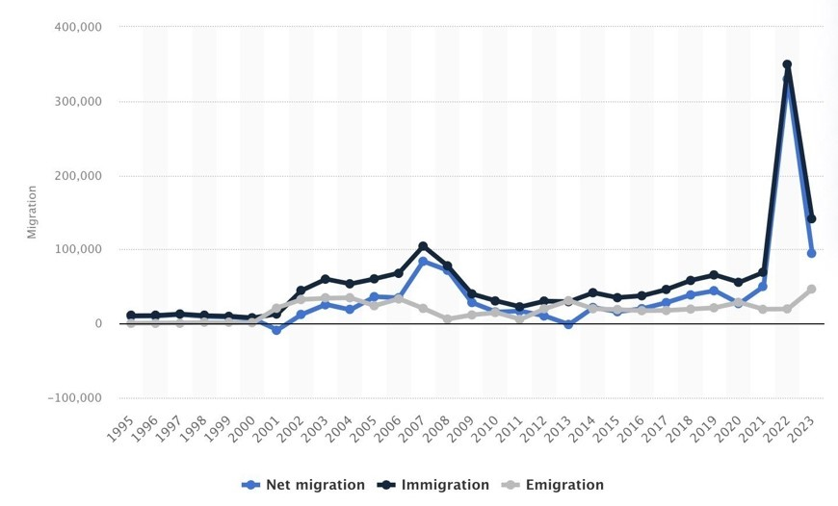

***Figure 2.1.*** *Net migration, emigration, and immigration in the Czech Republic since 1995. (Czech Statistal Office, 2024).*

Evidently, the Czech government is overwhelmed by this increase and is unable to provide the needed services. As a result, it relies on migrant integration centers to help provide those services who often also lack sufficient resources to meet this heightened demand. Consequently, these organizations are in need of alternate funding strategies (Frank et al., 2018).

# 2.2 Interplay of Popular Opinion and Economic Impact

Popular opinion can have a large impact on the perception of immigration and migrants themselves, as well as those non-governmental organizations who help tackle the issue of migrant integration.

In the Czech Republic, the public’s perception of immigration is volatile, and immigration is often viewed as a threat. The media does not help alleviate this sentiment as they increase xenophobia by frequently demonstrating a negative portrayal of migrants (Dodevska, 2021). Surprisingly, in the case of the Ukrainian refugees, public opinion proved to be more sympathetic and willing to offer aid, but only temporarily. As seen in *Figure 2.2*, of the citizens who support accepting refugees, a vast majority want them to return to their home country once conflict ends. This has resulted in the sentiment towards Ukrainian Refugees changing for the worse, and they can often have a harder time living in Czech scociety. Considering this, it may lead to more negative perceptions of foreigners, including migrants, overall (Dimitrov et al., 2023).

A study by Brozova et al. found that people have a harder time accepting refugees into their country when the stay ends up being permanent (Brozova et al., 2018). The participants in these focus groups generally lacked personal experience with refugees, relying heavily on the media for information. The biggest concern is the impact on safety and integration, with a significant fear of cultural differences, particularly with Muslim refugees (Brozova et al., 2018).

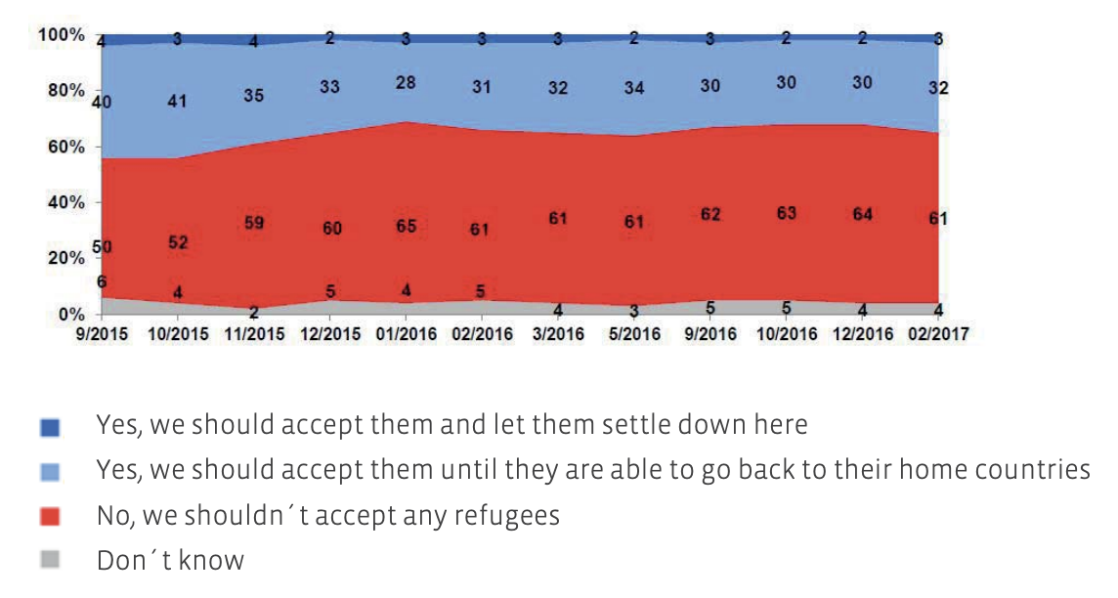

***Figure 2.2.*** *Study shows that Prague inhabitants feel negatively about refugees of war. The majority of opinions are negative as shown by the red color. (Brozova et al., 2018).*

As *Figure 2.2* shows, almost 60% of Czechs had a negative response to accepting refugees into the country. When asked if they would take them until they could go back to their home countries, only about 35% responded in agreement (Brozova et al., 2018). Due to this negative perception, NGOs that support the integration of migrants often face hostility (Čtk, 2018).

Political influence is a major factor in the negative perception of NGOs, often leading the public to misunderstand organizations' role and responsibilities. Mnay NGOs blame former president Václav Klaus’s attitude and understanding of democracy for the wave of rage towards organizations that help migrants. This belief stems from his public statement assuring that only the Czech government would know what is best for the country. The public attitude towards nonprofits is unfavorable – not only in the Czech Republic but in the whole region as well. To contribute to these negative opinions, there are anti-migrant parties in the Czech Republic (Zogata-Kusz, A. 2022).

Economic conditions can also affect the success of NGOs (Čtk, R. 2018). Statistics indicate that government support for NGOs remains limited despite the Czech Republic's economic growth, and this shortcoming fails to meet an increasing demand for their services (OECD, 2023). Limited financial support is provided to NGOs by the Czech Republic, forcing them to resort to alternate sources of funding such as international services like the EU Asylum, Migration, and Integration Fund (AMIF) as well as private donors (Vláda České Republiky, 2022).

# 2.3 Integrační Centrum Praha (ICP)

One Czech non-governmental organization that helps integrate migrants is Integrační Centrum Praha (ICP). Established on March 14th, 2002, it is now one of thirteen migrant integration centers in the city of Prague — their central branch is in Prague 1, and two other branches are in Prague 13 and 14. They offer free services meant to help migrants adapt to Czech society (Prague City Hall, n.d.).

One of the services offered by the organization is Czech language courses tailored for both adults and children. To obtain residency, adults participate in courses specialized in grammar and conversations to pass an A1 language proficiency exam, while children participate in interactive classes where they can form new friendships. Another service offered is socio-cultural courses, where migrants learn about Czech history, culture, and traditions (Prague City Hall, n.d.).

ICP also organizes cultural events to connect migrants with locals to help mitigate tension between both groups. Moreover, they also provide legal counselling to help with documents, residency applications, and civil proceedings. Through these services, Integrační Centrum Praha integrates thousands of migrants into Czech society (Prague City Hall, n.d.). To fund these efforts, ICP relies heavily on the Asylum, Migration and Integration Fund (AMIF) – which consists of the European Union and Ministry of Interior – and the Prague City Council. However, the majority of these funds are restricted to project-based proposals and are not allowed to be used towards ICP’s structural or operational costs. As a result, Integrační Centrum Praha has expressed their need and desire to pursue more flexible sources of funding.

# 2.4 Sources of Funding

Given the restrictions imposed by many current funding sources, ICP wants to find alternative sources of funding that have more flexibility in their expenditure. Non-governmental migrant organizations that operate in the Czech Republic have many ways in which they can acquire funding. The most common form of funding is from governmental grants, which can come from local or international governments. However, sources of funding within the private sector, crowdfunding, and within the general public can provide less restrictive funding for NGOs within the Czech Republic

There is wide agreement that NGOs in post-socialist countries were struggling financially and lacked sufficient manpower. In response, the European Union (EU) Cohesion Policy was passed to provide financial assistance which opens new sources of funding (Potluka, O. et al. 2017). Specifically, it targets all regions and cities in the EU to support job creation, business competitiveness, economic growth, sustainable development, and improvements to citizens’ quality of life (European Commission, 2021). Despite the investment in the EU Cohesion Policy – combined with NGOs’ participation in implementing these policies – only a minor part of the funding is distributed among NGOs, and there is no empirical evidence that shows that this support helps to increase NGOs’ capacities (Potluka, O. et al. 2017).

As a result, organizations often turn to many grants that are available within the EU. The Asylum Migrant Integration Fund (AMIF) supplies funding to countless organizations across Europe through a request and approval system. Though helpful, this leaves many NGOs with inconsistent funding as each project must be approved before financial support is given. Only a proportion of the funds requested are granted before a project starts, whereas the rest is reimbursed after its completion. To receive this reimbursement, a separate proposal that reports exactly where the funding is allocated as well as an analysis of the effectiveness of said efforts is required. Furthermore, these funds are controlled in how they can be spent, with required public transparency and recurring on-the-spot checks. In all, the very nature of this grant means that NGOs that receive this funding are unable to use it for logistical purposes or other needs of their organization (AMIF, 2023), (European Commission, 2024).

Since these funds are so restrictive, other methods of funding are required to allow NGOs to make any organizational or operational improvements. The first source of funding that will be discussed are those within the private sector – specifically, international and non-governmental funds. These funds often come in the form of large donations from institutions who often support a wide range of initiatives, especially those who share similar missions. These sources are often less restrictive than governmental funding, allowing NGOs to allocate resources more strategically to meet their needs (Foundation Source, 2023). In addition, NGOs can turn to partnerships with other private corporations. Specifically, private companies that have large migrant workforces often partner with migrant-based NGOs that can help integrate their employees into their respective societies. In return for services such as language courses, socio-cultural lessons, or social counselling, these companies often donate large sums of funds. These funds from the private sector are a good example of non-restrictive funds.

The second funding source is crowdfunding, which is rooted in crowdsourcing and microfinancing. Although crowdfunding is a relatively new concept in the Czech Republic, traditional crowdfunding is well-developed, with many platforms available worldwide. Since non-governmental organizations face resource insufficiency in post-transitional Czech society, it is a viable funding avenue for NGOs to explore (Svidroňová et al., 2020), (Richter, 2014).

Varying from traditional funding methods, which usually pertain to receiving large amounts of money from a few sources, crowdfunding is the collection of small sums from a large group of people. Startups, growing businesses, and NGOs often use crowdfunding to access alternative funds. Crowdfunding platforms are websites that enable interactions between the crowd and fundraisers. It can be a way of cultivating a community and accessing new customers around the offerings. Typically, crowdfunding platforms charge fundraisers a fee, especially if the campaign has been successful. In return, there is the expectation that the platforms will provide secure and easy-to-use services. Donation-based crowdfunding is a model in which individuals donate small amounts to meet the larger funding aim of a specific project without receiving any financial or material return (Zhang, n.d.).

Crowdsourcing is a framework that gathers a large and decentralized group of people for various reasons, such as gathering data, solving problems, or addressing challenges. Today, these interactions typically occur on digital platforms such as social media and smartphone apps. The concept of crowdsourcing—using a group to solve a problem is centuries old. This concept is based on the idea that a diversified group of people often achieves better results more efficiently than a smaller and more homogenous population. There are many benefits to crowdsourcing, such as improved quality, faster solving of complex problems, and lower project costs through leveraging the skills of a vast pool of people. Companies like Starbucks and Samsung have used this technique before (Greengard, 2024). In 2014, crowdsourcing became a popular financing tool among Czechs. Many mainly artistic and cultural projects have been backed through Czech crowdsourcing sites. The Czech Republic became a leader in community funding among central European countries. It also became a leader in using alternative financial instruments (Richter, 2014).

Crowdfunding that contains a microfinancing approach can be beneficial to NGOs. Microfinancing traditionally provides small loans to individuals or groups in underserved communities, primarily for entrepreneurial purposes. Combined with crowdfunding through the leveraging of platforms, NGOs can access small-scale funding as the financial responsibility is dispersed across a broader base of contributors. A blended model aims to enhance financial inclusion by providing a sustainable way to support small-scale projects. Crowdfunding platforms expand on the principle of microfinancing by making it easier for marginalized entrepreneurs to reach a global pool of potential funders. This eliminates geographical and institutional barriers, which enables funding access for even the most remote and underserved communities.

Additionally, the online nature of crowdfunding platforms means that if an individual has access to the Internet, they can create or contribute to campaigns. Digital models increase transparency, provide real-time updates to funders, and reduce the stigma sometimes associated with seeking financial help through microfinance. It also allows for contributions from anywhere in the world to fund projects that are align with their values, extending the reach of traditional microfinance (Svidroňová et al., 2020).

The last way in which NGO’s can acquire funding is from the general public. Organizations employ the use of a donate button on their respective websites to attract individuals to donate, as seen by two major migrant integration centers in the Czech Republic: InBáze and Organizace Pro Pomooc Uprchlikûm, in *Figures 2.3.1 and 2.3,2* (OPU, 2024), (InBaze, 2024).

***Figure 2.3.1:*** *Website navigation bar for Organizace Pro Pomooc Uprchlikûm that includes a ”Support Us” button. (OPU, 2024).*

***Figure 2.3.2:*** *Website navigation bar for InBáze that includes a ”Donate” button (*InBaze, 2024*).*

Migrant-based NGOs in the Czech Republic can leverage many sources of funding to fund their projects and operational costs. While governmental grants currently provide the most funds for ICP, they also come with restrictions and long proposals that need to be written and financial tracking that needs to be completed. That is why additional funding sources, like international and non-governmental grants, corporate partnerships, crowdfunding, and direct donors, are important for covering operational costs for NGOs.

# 2.5 Communication Strategies

Communication with its various constituencies is key to an organization's ability to secure support and funding. It is crucial for those NGOs that are engaged in social movements – they often rely on them to express ideas and engage support from complex social networks. An article about fourth-generation NGOs and their communication strategies reiterates the importance of communication strategies in helping achieve organizational goals and influence public opinion (Duong, H. T., 2017).

To begin with, strategic communication helps organizations tailor their messages to diverse stakeholders, ensuring that the information is relevant and foster engagement. These strategies also help bring awareness through targeted campaigns and NGOs can reach new donors – a factor that demonstrates their impact in building credibility to secure resources. As the non-profit sector becomes more competitive, communication strategies can help NGOs differentiate themselves and remain visible in a crowded field. To do so, NGOs need to use both traditional and new platforms. In particular, the use of social media, websites, and email campaigns helps these organizations reach larger, more diverse audiences effectively. Techniques such as storytelling, emotional appeals, and visual content can instill a sense of empathy and action within audiences (Duong, H. T., 2017).

Likewise, social media has become a significant part of many individuals' lives in recent years. Specifically, there are more than 4.8 billion social media users globally—nearly 60% of the global population. As a result, social media has become a crucial aspect of digital marketing strategies. Over 90% of business leaders have recognized that social media allows organizations to better understand customers, assists in building brand loyalty, and improves public relations (Pace University, 2024).

Despite these developments, it is important to find a balance with more traditional media platforms to reach a larger audience – some people might not use social media but still can be reached by other means of communication. Posters and flyers are cost-effective tools to communicate promotional messages or spread awareness to target audiences effectively. They can be used for various marketing campaigns, such as introducing new products, special sales, or events. Posters are suitable for long-term, wide-audience visibility, while flyers are effective for short-term campaigns or direct handouts. Overall, the success of posters and flyers depends on thoughtful design, strategic placement, and clear communication goals (Ladd, 2010). Nowadays, flyers can be used in both print and online forms. In fact, they account for a considerable portion of retail marketing budgets throughout Europe. Thus, they are an avenue for European NGOs to consider when developing marketing plans (Ziliani et al., 2022).

By utilizing both newer and traditional forms of communication, NGOs can reap the several opportunities they offer. It is important for NGOs to understand that the combination of several different platforms allows them to reach a much broader audience. However, it is just as important for them to understand the potential drawbacks of utilizing certain platforms, including the risk of exposure to hostility or loss of privacy. Only then will NGOs be able to utilize media platforms appropriately.

# 2.6 Summary

This research highlights the surge in immigration within the European Union due to the Russo-Ukranian War, as well as the Czech Republic’s participation in welcoming its migrants and refugees. As a result, the public’s perception on immigration and migrants themselves within the country has been a topic of controversy, and non-governmental organizations who help integrate and provide services to these migrants are faced with resistance. In addition, NGO’s often restrictive sources of funding hinder their ability to improve its operations. By examining ICP’s current funding and communications structures, the team identified potential alternative sources of funding and communications practices that will help ICP ensure continued success.

**3.0 Methodology**

This project found less restrictive funding strategies for Integrační Centrum Praha to ensure the organization's ability to improve its operations in the Czech Republic. To ensure the recommended sources of funding are most effective, ICP must simultaneously improve their communication to their various constituencies. The team accomplished this goal through the following objectives:

* Research alternative sources of funding that are less restrictive and will enable organizational improvements and suggest those sources for ICP to approach
* Understand ICP’s current communication strategies and compare it to other NGOs’ strategies in the Czech Republic to recommend changes

The team conducted research in Prague, Czech Republic, from October 21st, 2024, to December 13th, 2024. By following through with these objectives, the team identified more flexible funding sources for ICP while also identifying the strengths and weaknesses of ICP’s current communication strategies and comparing them to those of other NPOs within the Czech Republic. This understanding enabled the team to identify areas in which ICP’s funding and communication structures can improve, both of which were used to help the team recommend a viable plan with new sources of funding and communication strategies for Integrační Centrum Praha.

**3.1 Identify Alternative Sources of Funding**

Approximately 90% of Integrační Centrum Praha’s financial budget comes from the Asylum Migration Integration Fund (AMIF) – a fund made up of support from the European Union (EU) and Ministry of Interior of the Czech Republic. The remaining percentage of the organization’s budget is made up of support from the City of Prague and limited support from UNICEF. Although ICP receives a comfortable amount of funding from these sources, they are often highly restricted to project-based proposals, and do not enable any organizational improvements. In other words, ICP needs funding that permits financial freedom. For this reason, the private sector, crowdfunding, and the general public are all alternative areas in which ICP can obtain this type of funding.

**3.1.1 Private Sector**

There are multiple avenues of funding that the team investigated to find non-restrictive funds, with the first of these being the private sector. Specifically, our initial research and talks with ICP revealed two sources of private funding: private international funds and corporate partnerships. These international funds are needed to meet certain criteria to be used by ICP. To begin with, ICP needs to qualify for these funds. Additionally, given that ICP was founded by and still receives a portion of funds from the City of Prague, they are still considered to be a government-funded organization, which rules out many international funds, such as the Nordic EEA Grants. These funds also had to be non-restrictive to meet ICP’s goal, meaning at least a portion of the funds granted have to be able to be used for organizational improvements. Lastly, these funds are needed to share a mission that aligns with that of ICP, promoting the integration of migrants as to improve the likelihood that ICP gets approved.

Further research into additional sources of funding was conducted to identify other local funds or international funds that operate in the Czech Republic. Exploring publicly available documents provided by other migrant NPOs as well as other local NPOS that don’t specifically work with migrants granted new funding opportunities for ICP. This way, ICP is able to take advantage of funds that are already used by other NGO’s as well as new funds found by the team.

Another source of funding within the private sector that the team researched is that of corporate partnerships. As previously mentioned, ICP has already attempted to work with many corporations in the past, though none have proved successful. Below is the list of corporate organizations that ICP has tried to work with:

* Aero
* Epam
* Komwag
* Losteria
* Fujikoki Czech s.r.o.
* Takenaka
* Mitsubishi Electric Automotive Czech s.r.o.
* Riverside school
* Tawan
* Koded Stav

Given this list, the team investigated the corporations ICP has already attempted to work with to have a better understanding of what type of organizations ICP could work with in the future. Specifically, we mainly focused on the industry, likelihood of high migrant workforce, and proximity to ICP to assess the viability of other companies to recommend to ICP. This method was chosen as companies like the ones that they have worked with in the past are more likely to want to partner with ICP. In addition, many organizations like Nadace Via provide networking assistance and networking seminars – these seminars could be useful for ICP to find corporate partners.

**3.1.2 Crowdfunding**

To ensure that Integrační Centrum Praha can access websites that align with their objectives, the team explored 32 crowdfunding platforms operating within the Czech Republic. In doing so, the team considered several factors that revealed the most appropriate way for ICP to approach this matter. Firstly, the team wanted to ensure that the platforms were catered to NGOs somehow. Having ICP use a platform mainly for startups would not be effective in seeking funding. Next, the team analyzed the approaches the platforms had. The best platforms to use would contain both a crowdsourcing and microfinancing approach to crowdfunding. In terms of crowdsourcing, this was identified through how effectively they reach target audiences. Data such as how many people access their website regularly, how many funding campaigns they have aided to complete, and if they offer for potential donors to interact with the website, such as becoming an ambassador for an NGO or the ability to start funding campaigns in an NGO’s places. When it comes to a microfinancing-influenced crowdfunding approach, this was determined by the available donation tiers on the website. If sums started low, and if the donors had the option to pick the amount they would like to donate, this revealed a strong microfinancing approach. If the platforms mentioned did not meet most of these requirements, they were disregarded, as they did not align with ICP’s mission.

**3.1.3 General Public**

Building a connection with the general public is imperative for Integrační Centrum Praha’s (ICP’s) success in finding more flexible sources of funding. As Czech citizens tend to have a negative outlook and general distrust towards migrants, refugees, and those organizations that help them, making sure to build trust with broader communities and improving their public presence is highly important. This connection can then be leveraged by ICP into donors through the implementation of a donate button and donation page on ICP’s website.

Currently, ICP does not have a donate button on their website. Considering our initial research revealed that this is where most NGOs get a portion of their non-restrictive funding from. Before doing so, the team looked at other NGOs that do in fact have a donate button to gain insight into what donate buttons should look like and where they should be placed. It is important to also understand research behind this as well, as the design of these buttons and interfaces drastically changes donation rates (Sampougkasidis, 2024). Likewise, the team looked at other NGO’s donation pages, along with research, to determine strategies that ICP can implement to their donate button to maximize donations. Additionally, research into how to advertise the donation page provided ICP with methods to drive donors to their donation page, which ultimately will increase donations.

**3.2 Improving Current Communication Strategies**

To make appropriate recommendations for Integrační Centrum Praha to improve its communication strategies, it was first vital to understand how the organization is currently managing its respective department. In addition, it was important to conduct an analysis of other Czech NPOs’ communication strategies to understand how those organizations’ communication techniques align with their success. By pursuing these methods, the team hoped to identify and recommend potential improvements that could be made to ICP’s current communication strategies.

**3.2.1 ICP’s Current Communication Strategies**

The team's first step was to review ICP’s current communication strategies. Specially, the team had to initially organize an interview with an individual within the public relations department. To do so, the team asked for the said individual’s contact information and drafted an email to obtain valuable information about how ICP’s PR department operates. Prior to this interview, the team was already aware of the social media platforms ICP was involved in. In other terms, the team only had surface level information on the organization’s current communication strategies. However, the team wanted to gain more detailed insight into the kind of engagement it receives across all media platforms.

Likewise, the team was previously informed that the head of PR had access to all the organization’s media platforms. As a result, the team also wanted to know which data analytics platforms the organization has access to. The team hoped to utilize the tools provided to gain valuable and detailed insight into relevant information such as post-performance, follower demographics, engagement trends, and more. The outline for the interview can be seen in *Appendix A*. Having a good understanding of ICP’s communication strategies was imperative, as the new strategies that the team wanted to recommend are long-term and, therefore, impact the organization’s success significantly in a larger scope. It was also imperative to analyze other Czech non-profit organizations with similar missions in more depth.

**3.2.2 Other Czech NPO’s Communication Strategies**

After reviewing ICP’s current communication strategies, the team focused on how other non-profit organizations communicate with their intended communities. The team investigated the following migrant-based organizations in the Czech Republic: Organizace Pro Pomoc Uprchlíkům (OPU), META, and InBáze, as well as the following non-migrant-based organizations in the Czech Republic: Loono, Asistence, and Centrum Locika. Quickly, the team noticed that these organizations are all active on their respective websites, Facebook, Instagram, YouTube, and X accounts. By analyzing the content posted on these platforms and the engagement these organizations receive, the team gained a better understanding of strategies that perform well. An effective analysis tool provided valuable insights into audience engagement, growth trends, content performance, and competitive benchmarking. The analysis tools that the team used were BuzzSumo and Social Blade (BuzzSumo, n.d.) (Social Blade, n.d.).

However, it is important to note that as a third party to these said organizations, the team was only able to obtain surface-level information. As a result, the team sent out the email prompt depicted in Appendix B. Only one organization was willing to do the interview – MigAct. The team interviewed the co-director of the organization – following the guidelines in Appendix A – and obtained some useful responses as to how they operate in terms of communicating with the public. We then used this knowledge in order to complete our recommendations section.

# 4.0 Results

In the following sections, the team will discuss the results found by carrying out the initial objectives – this included finding Integrační Centrum Praha (ICP) alternative, less restrictive sources of funding and recommending improvements to its current communication strategies. The team will then have defined a new funding and communication strategy plan.

# 4.1 Funding Strategies for ICP

The team conducted thorough research to identify less restrictive sources of funding that would be appropriate for ICP to approach. Based on initial conversations with the sponsor, the team was able to identify several avenues relevant to the organization’s need but narrowed down to three. The three funding strategies the team decided to expand upon were those found within the private sector, crowdfunding, and the general public. The first to be explored were those within the private sector, yet more specifically private institutions/funds and corporate partnerships. The team also performed research into crowdfunding, where the team explored different existing options within the Czech Republic. Then, the team evaluated the possibility of forming an individual donor base with the general public by using a donate button. Through these efforts, the team was able to create a new funding plan for ICP.

# 4.1.1 Within Private Sector

The first source of funding is the Visegrad fund, or more specifically, the V4Gen Mini Program. This is project proposal-based and allows up to 15% of funds to be used for overhead costs if the cost was incurred during the project timeline. In addition, the organization advises using other funding sources with their fund as it's unlikely that this single grant will cover the cost of an entire project. This means that money from this fund can be used while also using funds from AMIF or other opportunities (Ministry, n.d.). However, a downside with this fund is that the project must involve at least two entities from different V4 countries (Czechia, Hungary, Poland, and Slovakia). In other terms, an NGO located in the Czech Republic would only be able to apply for this fund if partnered with another organization in Hungary, Poland, or Slovakia. In the case that an NGO can create such cross-border cooperation, that NGO can apply to the fund and use a portion of the funds towards their operational and logistical costs (Ministry, n.d.).

Another source of funding is Nadace ČEZ – a fund that provides annual grants for the betterment of Czech society. The team has found that NGOs within the country can make use of the Support for Regions Grant and the Non-Profits - Professional Development of Social Care Grant. Due to the Regional Development grant’s broad nature, the organization provide funds to any legal entity that the organization believes benefits the Czech Republic. On the other hand, the Non-Profits - Professional Development of Social Care Grant provides up to 200,000 CZK (approximately $8330 USD) to Czech NGOs specializing in social care, prevention, or counseling. This fund, unlike the Visegrad Fund, is not dependent on a project proposal, and can entirely go towards funding an organization’s operational and logistical costs (Forrest, 2024).

The team also discovered several funds that run one-time, non-reoccurring grants and projects that NGOs can approach. Nadace OSF and the European Philanthropic Initiative for Migration (EPIM) are two funds that have both offered similar grants in the past. These grants are relatively straightforward, share similar application processes, and allow a portion of funds to be allocated to organizational costs (EPIM, 2023), (Nadace OSF, 2019).

Prior to applying to the following international funds, it is important to recognize some constraints when pursuing this form of funding – the most important being double funding. Double funding can result in organizations losing credibility, be automatically denied further funding opportunities, or even cause legal action against the organization (Ward et al., 2021).

Many of the funds researched include funding a project with multiple funding sources, so it is important to avoid double funding. Double funding refers to receiving funds from two different grants or sources meant to fund the same program costs and is against many regulations. As a result, it is imperative to ensure that each fund covers distinct project expenses. Transparency in utilizing acquired funds is crucial, not only for maintaining trust with granting agencies and funding sources, but also for ensuring accountability to the public, as required by most agencies. Consulting with representatives from any agencies that will be funding the same project can provide insight into how not to break any guidelines and avoid double funding (Ward et al., 2021).

NGOs that provide various support services, such as language instruction, cultural adaptation programs, and legal assistance can attempt to partner with various corporations. This is typically achieved by offering these said services to another organization’s mostly migrant workforce, in exchange for financial compensation. This strategy is one that Integrační Centrum Praha (ICP) has already attempted – no potential partnership has ever gotten past the talking stages. For this reason, the team conducted an analysis into ICP’s attempted corporate partnerships to help gain a better understanding of the opportunity.

Specifically, ICP has attempted to work with 9 Czech companies in the past: Aero, Epam, Komwag, Losteria, Fujikoki Czech s.r.o, Takenaka, Mitsubishi Electric Automotive Czech s.r.o, Riverside school, Tawan, Koded Stav. These companies operate in many sectors, like engineering, manufacturing, construction, hospitality, and education. What these corporations have in common though is their high percentage of migrant workers. Though their worker composition is not made public, ICP has stated that this is the main reason for attempting to work with them. For ICP to find new corporate partnerships, it is important to understand what industries have the most migrant labor in the Czech Republic.

There are 4 main sectors in the Czech Republic that have a large percentage of foreign workers, mostly in low-skilled labor jobs: Administrative and Support Services at 54% foreign workforce, Construction at 28% foreign workforce, Accommodation and Food Services at 25% and Manufacturing at 16%. These areas are only continuing to grow, most of which seeing around a 1% increase in foreign labor per year since 2010 (Drbohlav, 2003), (ČTK, 2021), (Hora, 2019). These findings were used to assess which sectors our team would search for corporations in and how promising each recommendation was. Considering the opportunities available from private institutions and corporate partnerships, the team will provide appropriate recommendations in Section 5.0.

Through talks with ICP, the team has gained a full understanding of how they have tried to partner in the past. So far, the idea of providing integration services for monetary compensation has not gotten past the talking stages. Often, a meeting between ICP and the desired company will happen, and nothing will come of it. This is because ICP does not have many business contacts with which they are able to build relationships and trust with. According to ICP, most of these failures occur due the lack of trust and a lack of knowledge about ICP.

One way in which ICP would be able to find companies looking for ICP’s services would be through networking. If approved, Nadace Via offers free classes for individuals within non-profit organizations that help with networking and gets you in contact with a support network of like-minded people that work at other non-profits or run volunteer events. To get past this so-called talking stage and to find new lasting partnerships, our team has devised a set of recommendations to be explained more in *Section 5.0*.

# 4.1.2 Within Crowdfunding

Crowdfunding is another good alternative for ICP to explore. This is because it requires minimal effort to collect funds. The funds collected through this avenue would also be less restrictive depending on the way campaigns are framed, allowing ICP greater financial freedom for structural organization than previously. Studies show that campaigns generally achieve or exceed their goal on crowdfunding platforms. In fact, projects often achieve 1.17 times their goal. The age of the organization and its establishment size did not affect its success with crowdfunding (Svidroňová et al., 2020).

The first promising platform we explored was Nadace Via. This organization is a Czech fund that funds projects that improve communities within the Czech Republic. It promotes fundraising campaigns for its subsidiary company, Darujme.cz, which it runs. Via will match up to CZK 20,000 ($910) of funds raised per project on Darujme.cz. In addition to financial support, it also offers learning seminars and networking sessions to NGOs (Nadace Via, 2020).

Darujme.cz currently works with over 1,000 NGOs within the Czech Republic. They have a crowdsourcing and microfinancing approach through various aspects of their organizational structure, making them a perfect candidate for ICP. Their page discusses their mission by targeting key aspects of crowdsourcing and microfinancing. As shown in *Figure 4.1.1* below, they include promoting the non-profit organizations they display on their platform, offering the possibility to help these non-profit organizations receive funding through becoming an abassador, and asking for donations to aid the non-profits in receiving funding. In 2023, Darujme.cz helped 1313 organizations with their 5605 donation campaigns by collecting more than 431 million crowns from 209 thousand donors (Darujme.cz, n.d.).

***Figure 4.1.1:*** *Darjume.cz front page. (Darujme.cz, n.d.).*

Darujme.cz suggests donations of 10, 30, and 50 euros, but there is also the option for a donor to choose the amount a donor wants to give to an NGO. They also do not take processing fees, allowing NGOs to maximize their income from crowdfunding on their platform. InBáze, another Czech migrant NPO, currently utilizes this crowdfunding platform. Loono and Centrum Locika, two successful NGOs in the Czech Republic are also currently on Darujme.cz (Darujme.cz, n.d.).

Another platform that may be a feasible way for ICP to collect funding is WhyDonate. There is a 0% commission when creating a project. However, unlike darujme.cz, they charge 0.25 euros plus an additional 1.9% fee for each donation. Furthermore, they allow for microfinancing possibilities. According to their website, donations start at 5 euros and go up from there (WhyDonate, 2024). WhyDonate has a strong crowdsourcing approach, as its platform reaches a large community. Why Donate gets more than one million visitors in a month on its website, has more than 876,175 active donors and has helped start more than 51,340 fundraising campaigns. They also offer the possibility to start funding campaigns instead of NGOs, increasing the potential of website interaction. Unlike Darujme.cz, they do not require project proposals to start a fundraiser. A fundraiser could have a name such as “help ICP integrate migrants” and be acceptable to start a fundraising platform. Generally, the current fundraisers that they have up seem to be doing well, as they are close to their set goals. Their website offers various features to their funding platform users, as shown below in *Figure 4.1.2* (WhyDonate*,* 2024).

***Figure 4.1.2:*** *Why donate front page. (WhyDonate, 2024).*

When creating a crowdfunding platform on WhyDonate, there is the option to create a fully customized fundraising experience from start to finish, complete with a company’s branding. Additionally, there are easily tailored fundraising pages with custom content, logos, colors, images, and buttons. On top of that, custom emails to donors and fundraisers can be tailored by changing the branding and text of emails. WhyDonate also offers the creation of donation QR codes and fundraising payment links. WhyDonate is also a global crowdfunding that is available in 27 different countries and reaches 850,000+ donors and 1,000,000+ visitorsper month. It offers various payment methods, reccurring donation setups, and multi-language support. WhyDonate offers support in multiple languages and has an entire page that explains various crowdfunding models, methods to promote NGO brand formation, and more (WhyDonate, 2024).

Overall, both Why Donate and Darujme.cz have various aspects that may be promising for ICP when looking to create a strong crowdfunding approach to finding funding. Darujme.cz, through Nadace Via, has a mission to aid NGOs in securing funding through crowdfunding. ICP is an NGO that needs to secure alternate funding which fits the brand perfectly. ICP also needs aid when it comes to branding and promotion of themselves. WhyDonate offers various and extensive aid to NGOs to create a platform, brand, and donation promotions, which is perfect for ICP to utilize.

# 4.1.3 Within General Public

Another way for NGOs to get restriction-free sources of funding is through developing an individual donor base – this is typically accomplished through the implementation of a donate button on their respective website. By coupling the use of this button with media platforms, individuals can be guided to a donation button. It is important to note that ICP currently does not make use of a donate button on its website. In this section the team will discuss what makes a good donation button and page, using an article on design choices that increase NPO donations as well as research from the Metropolia University of Applied Science in Finland about increasing donations with website design.

To begin with, donate buttons are often successful and lead to increased donation when there are methods set in place to increase the button’s visibility. Incorporating the donation button into a website’s menu bar at the top ensures that it is always visible when navigating the site and is a simple way to increase donations significantly. Additionally, providing a user with multiple ways to get to the donation page on a website also increases the number of times a user is prompted to donate. However, it is important to not overdo this too much (Huntsberger, 2023), (Sampougkasidis, 2024).

Moreover, the color of the button can evoke different emotions within potential donors. For instance, green is often associated with sustainability, while blue conveys dependability. Conversely, a bright red button may signal potential donors to ‘stop’ and lead to a decrease in clicks if not careful. These findings also extend to an organization’s brand, as the colors it uses to decorate its website, logos, and social media, can change how it is perceived (Huntsberger, 2023).

Another design choice is a call to action – a marketing term used that prompts a viewer, listener, or donor to complete a certain action. This often takes the form of phrasing, telling an individual to donate (Huntsberger, 2023), (Sampougkasidis, 2024). Specifically, rather than labeling the button “Donate” or “Donate Here”, naming it something that generates curiosity within the potential donor can greatly improve donor rates. Some examples of this include “Donate Now”, “Support Us”, "Make a Difference", or "Support Our Mission". All these phrases prompt the visitor to donate, calling them to perform the action of donating. For visual examples of what makes good donation buttons, please see *Figures 4.1.3* and *4.1.4*

***Figure 4.1.3:*** *Organizace Pro Pomoc Uprchlíkům donate button (OPU, 2024).*

***Figure 4.1.4:*** *Kroky Dobra Donate Button (*Kroky Dobra, n.d.).

Once the user has clicked the donate button, the next step is getting them to put their card information in to donate. There are a multitude of ways to increase the number of people and the monetary value of donations through pure website design. The first donation page design choice is donation tiers. Having prompted donation tiers, such as 250 CZK, 500 CZK, and 1000 CZK, prompts users to think that's what other people are donating. Additionally, labeling each tier with what that amount of money could do for your organization prompts people to donate more. For example, let's say the cost to run one language course was ~500 CZK; labeling the 500 CZK tier as “pays for a language course for X migrants” will cause an emotional connection with the donor and build trust. This tiered system also reduces friction through the donation process as a click is easier than entering another amount into the “Other Donation” text prompt (Sampougkasidis, 2024). For a good example of a donation page, see Centrum Locika’s donation page in *Figure 4.1.5*.

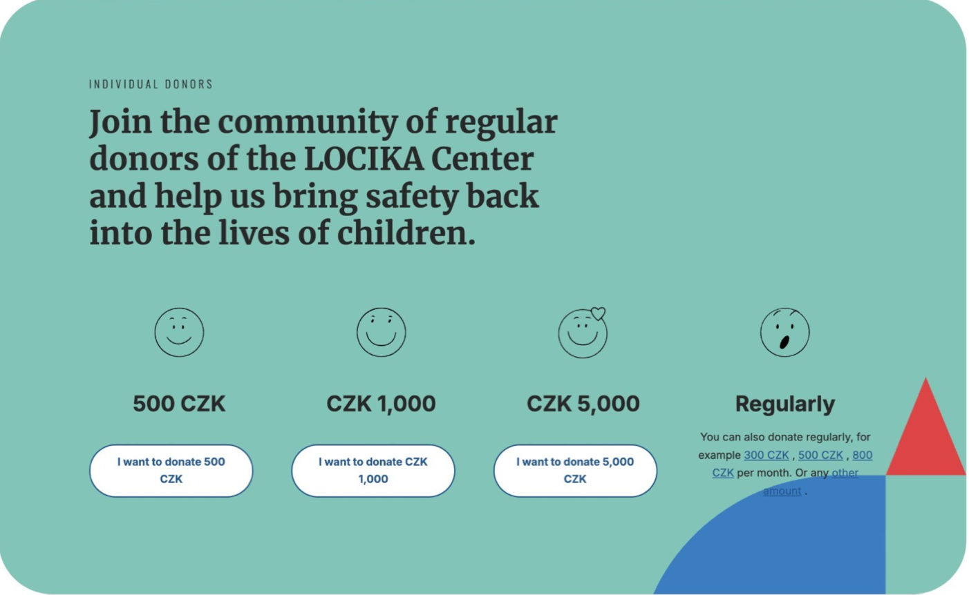

***Figure 4.1.5:*** *Centrum Locika’s donation page is a good example of what makes a well-designed tiered donor system. (Centrum Locika, n.d.).*

This leads to the second method of increasing donors: reducing friction. Donating should be as easy as possible. It has been shown that the difference of one extra click can affect donation rates. This means donors should go from the home page to the donation page and then to the payment page. That’s it. The more steps, boxes, and buttons the user must interact with, the more chances the donor has to change their mind or decide it's not worth the effort (Huntsberger, 2023), (Sampougkasidis, 2024).

The third method of increasing donations comes from building trust. Including information about the use of funds, infographics about what funds go towards, donor testimonials, and success stories help build credibility. This credibility makes new donors more confident in their donations and increases the amount and frequency (Sampougkasidis, 2024).

Imagery is also important. Not only the donate page but also including images and videos of ICP’s work in action all over the website increases credibility and causes the user to have more of an emotional connection with ICP, making them more likely to donate (Sampougkasidis, 2024). For examples of how to successfully use imagery to build trust and create an emotional connection with donors, see Centrum Lodika’s “Support Us” page and ADRA.cz’s main page in *Figures 4.1.6* and *4.1.7*, respectively.

***Figure 4.1.6:*** *Centrum Locika uses imagery very well to create an emotion connection with the webpage visitor, making it more likely they donate. (Centrum Locika, n.d.)*

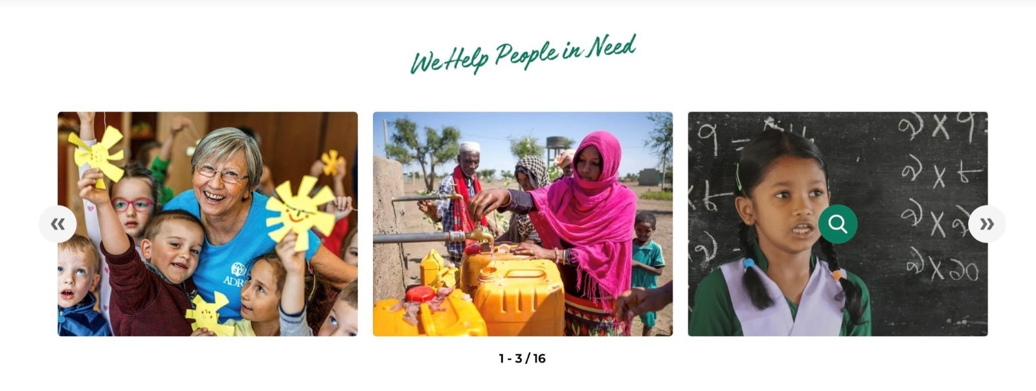***Figure 4.1.7:*** *At the bottom of ADRA.cz’s main page, there are 16 cycling photos showing what their organization is working on, building trust with visual results. (ADRA, n.d)*

Lastly, making donors feel appreciated is very important. A simple “Thank You” page after a donation is complete greatly increases the likelihood of repeat donors. Additionally, setting up reoccurring payments, specifically tiers lower than the single donation tiers, like 50 CZK, 100 CZK, and 200 CZK a month, for example. This donation method also can be improved by the previous methods, such as labeling the 100 CZK a month donate tier with “For just 100 CZK a month—the cost of a cup of coffee—you can provide essential support to help a child build a brighter future in their new home” (Sampougkasidis, 2024).

All of these methods collectively increase donation rates, but they won't work alone. People need to know that they can donate to ICP. This means advertising the donation page whenever possible, including links under social media posts, in your social media bios, QR codes on flyers, links at the bottom of the email newsletter, etc. Any way that people can be directed to the donation page will increase first-time, returning, and recurring donations.

# 4.2 Communication Strategies for ICP

The team conducted a qualitative structured interview and social media analysis. Specifically, the team interviewed the head of the Public Relations (PR) department with questions tailored to understand the media platforms utilized by the organization as well as its intended audience. By conducting this interview, the team was then given access to the organization's social media analytics tools – this consisted of understanding ICP’s outreach, follower demographics, and successful posts. The team then reached out to and analyzed how other Czech organizations communicated with the public. Through these efforts, the team was able to create a new communication strategies plan for ICP.

# 4.2.1 How ICP Communicates with the Public

Integrační Centrum Praha currently struggles to reach its primary audience across all forms of communication, as well as reach any other secondary audience – including through both social media platforms and more traditional media. The team quickly realized that the organization’s social presence is not strong. To offer appropriate solutions, the team intended to first understand relevant information such as post-performance, follower demographics, engagement trends, and more. To do so, the team scheduled a meeting with the head of ICP’s public relations (PR) department to conduct a qualitative structured interview. By conducting this interview, the team hoped to learn more about their prioritized media platforms, the respective strategies used for each, and their target audiences. The team also hoped to gain access to the organization’s social media platform analytics tools, or more specifically, Meta Content Analytics (Instagram and Facebook) and YouTube Analytics. The outline of the interview can be found in *Appendix A –* the team’s findings will be discussed in the following paragraphs.

ICP reaches its audience through both social media and more traditional media platforms. In terms of social media, the organization primarily utilizes Instagram, Facebook, and YouTube, wherein they post differentiated forms of content based on the platform. Specifically, on Instagram they typically post entertaining photos and stories, whereas on Facebook, they post more informative content and often share posts from other alike organizations. On YouTube, they post longer and more professional forms of content, where they aim to post 10 videos per year. Fortunately, the team was granted access to those social media analytical tools mentioned. On the other hand, ICP utilizes newsletters and considers it the most effective method of communication as it is cheap and accessible. In other words, the organization prints material and distributes to different institutions to reach a wider audience. Considering that all platforms benefit from different forms of content, understanding ICP’s preferred platforms is important for the team to provide relevant recommendations. However, there are several other factors that must be considered first.

As expected, ICP’s primary audience are those foreigners from non-EU countries – this group is made up of those individuals who are integrated into Czech society with the help of the organization’s efforts. However, ICP's secondary audience are those residents of Czech Republic. Specifically, the organization utilizes its media platforms in hopes of educating them to reduce hostility towards migrant groups. By using Meta Content Analytics and YouTube Analytics, the team was able to understand ICP’s follower demographics across its respective platforms, displayed in *Figure 4.2.1*.

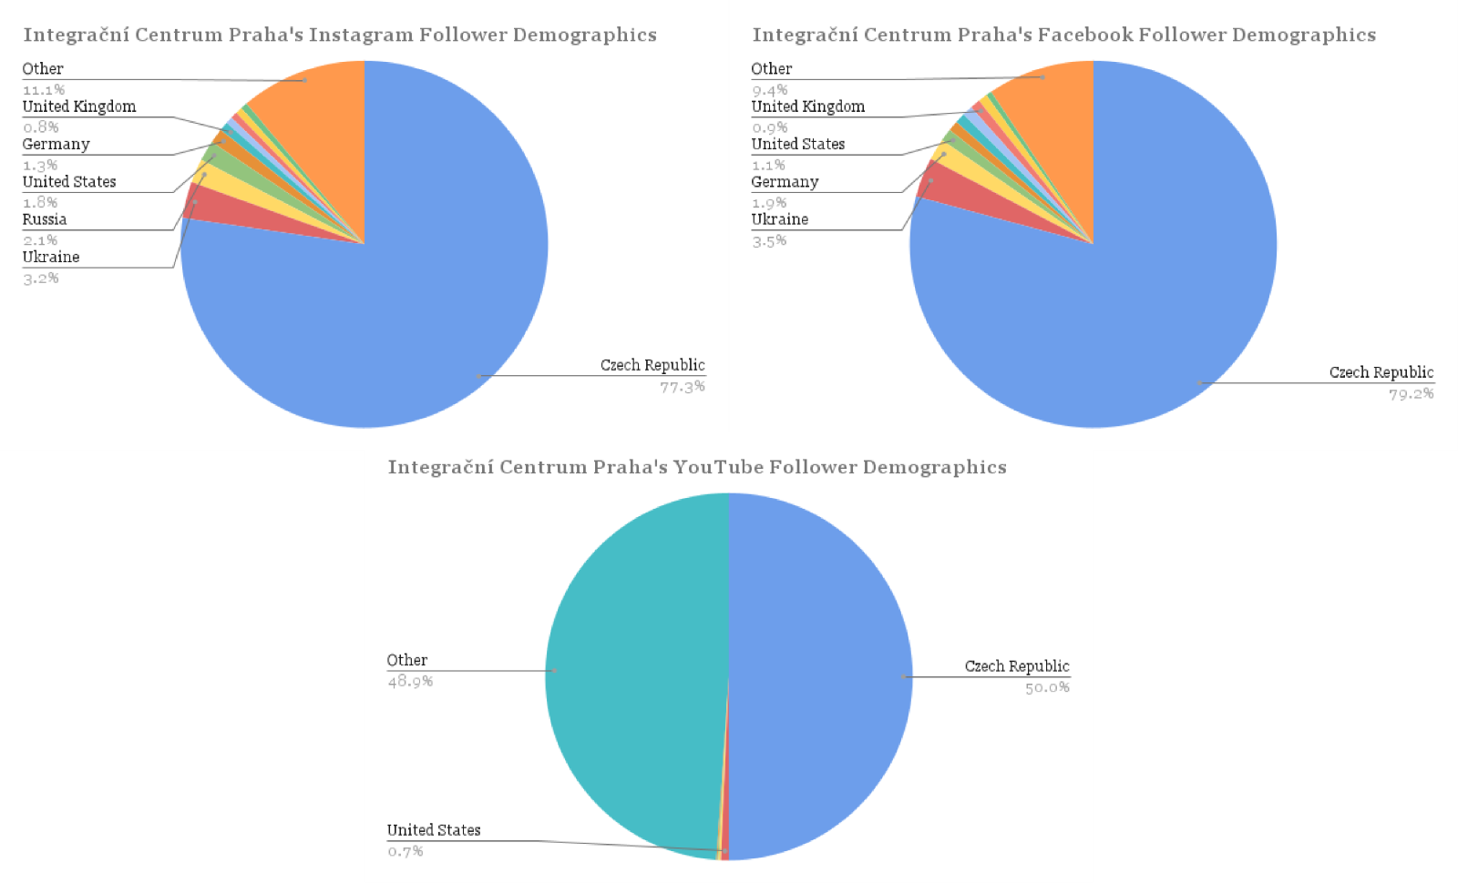***Figure 4.2.1:*** *Integrační Centrum Praha’s Social Media Follower Demographics*

With this information, it is difficult to understand whether ICP is reaching its primary or secondary audience. As a result, the team composed a survey to gain insight into ICP’s audience demographics. This survey can be found in *Supplementary Materials B: New Communication Strategies Plan*. Nonetheless, both analytical tools revealed that the organization receives limited engagement across all media platforms, and the team believes the problem stems from a lack of human resources. The interview disclosed that the PR department consists of two individuals – the head of the department and her part-time colleague. The colleague records videos and does graphic design, and together, they plan the organization’s posts. However, the small size of this department limits the organization’s ability to interact with its targeted audience.

The department attempts to respond to direct messages and comments, but they often struggle to respond to everything. To counteract this issue, the department currently has an automated response system to guide people to ask questions through emails. Although it provides an alternative, it is not the ideal solution as the organization fails to have human-created responses – this leaves significant room for improvement. ICP’s offices are distributed across the city of Prague, which makes it difficult for the department to create content from everywhere. The department needs an individual who is available to work full-time to be fully present; however, ICP is aware of this. The organization is currently working with a paid external agency to analyze its current efforts and offer improvements to its brand. For this reason, it is imperative that the team also analyzes how other Czech NGOs successfully communicate with the public.

# 4.2.2 How Other NGOs Communicate with the Public

To begin with, it is important to note that the team tried reaching out to other NGOs – such as META, OPU, Inbáze, Locika, Loono, Asistence and MigAct – in order to get an interview with their respective PR departments. However, only two of them replied – META, who didn’t have enough time to meet with us and MigAct, who agreed to the interview. As a result, the team conducted a third-party analysis on the other orgaizations’ media platforms. After performing said analysis, using SocialBlade and BuzzSumo, we obtained their engagement rates, the best day to post and their average engagement per post type and character range. Overall, the numbers are low and similar to ICP’s. In this section the team displays the graphs showing the engagement rate of each NGO for their Facebook pages (BuzzSumo, n.d.).

***Figure 4.2.2.1:*** *META’s Facebook engagement and posts published over time. (BuzzSumo, n.d.).*

As shown on the graph 4.2.2.1, the months when they posted more videos are where there is a higher engagement. In May and June, the engagement decreased because they stopped posting so often which led to a decrease in followers. This is the reason why they haven’t been able to bring back up engagement numbers (BuzzSumo, n.d.). This information reveals that in order to keep a constant engagement, ICP must post regularly.

META is the NGO with a higher social media presence, having accounts on Instagram, Facebook, X (Twitter), YouTube and LinkedIn. They have almost three thousand followers on Instagram and twelve thousand on Facebook. Although they have less than nine hundred subscribers on YouTube, they do have some videos with thousands of views. After analyzing them, we concluded that videos with educational purposes tend to reach a higher audience.

***Figure 4.2.2.2:*** *OPU’s Facebook engagement and posts published over time. (BuzzSumo, n.d.).*

The graph in *Figure 4.2.2.2* displays a steady engagement over time for OPU’s Facebook page, although there is a distinct peak in March 2024 (BuzzSumo, n.d.). This increase in engagement can be linked to the Pact on Migration and Asylum, in March the Commission adopted a Communication assessing the progress made. Along with this, some NGOs supporting migrants received more attention from the public.

***Figure 4.2.2.3:*** *InBáze’s Facebook engagement and posts published over time. (BuzzSumo, n.d.).*

The first thing that draws attention from graph 4.2.2.3 is how higher engagement is in comparison to how much they post. This means that the quality and efficiency of their posts is better. Their posts are very graphic, they choose short sentences and a photo that depicts what they want the public to know. ICP could adapt these formats to their posts.

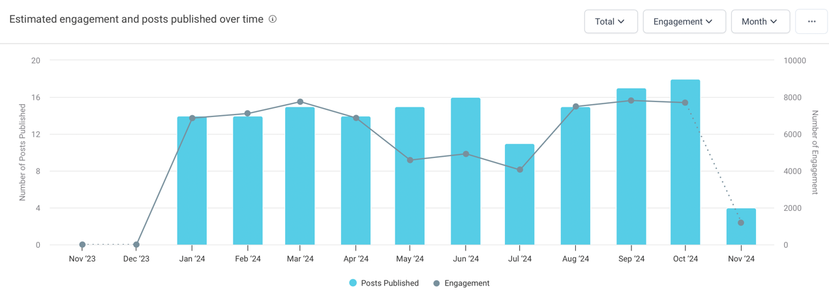

***Figure 4.2.2.4:*** *Centrum**Locika’s Facebook engagement and posts published over time. (BuzzSumo, n.d.).*

The graph in *Figure 4.2.2.4* presents a high engagement over time. In fact, it has the highest engagement rate being 3.25% in their Instagram account, while having 433 average engagements on Facebook (Social Blade, n.d.) (BuzzSumo, n.d.). The team benefited from going over their posts, and gave ICP some recommendations in the deliverables section about the type of content they should post.

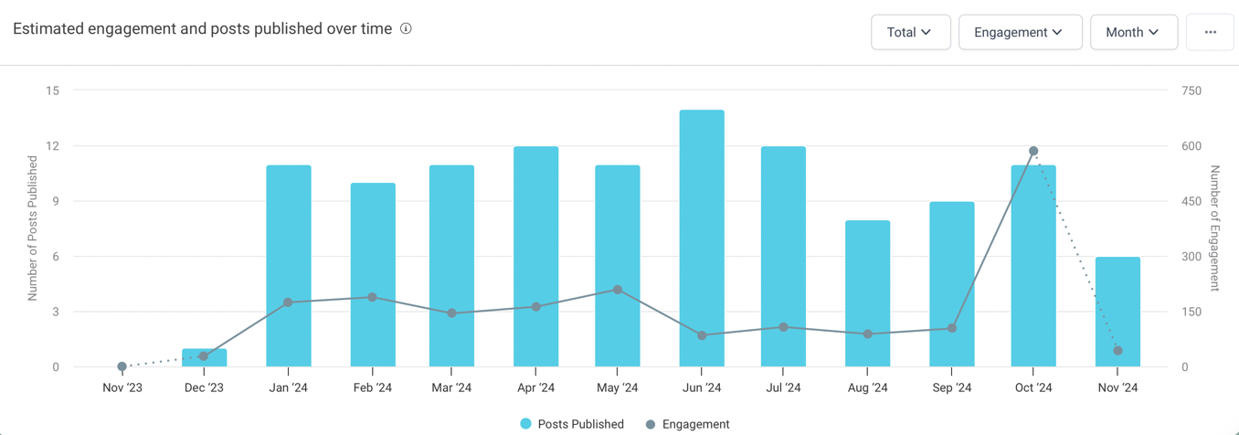

***Figure 4.2.2.5:*** *Loono’s Facebook engagement and posts published over time. (BuzzSumo, n.d.).*

Loono has over 22 thousand followers on facebook, however – as graph 4.2.2.5 reveals – their engagement numbers are generally really low. They tend to post almost every day which can be overwhelming for followers, resulting in a shorter time frame for them to interact with every post (BuzzSumo, n.d.). This analysis concluded that Loono is not the best option for engagement improvement.

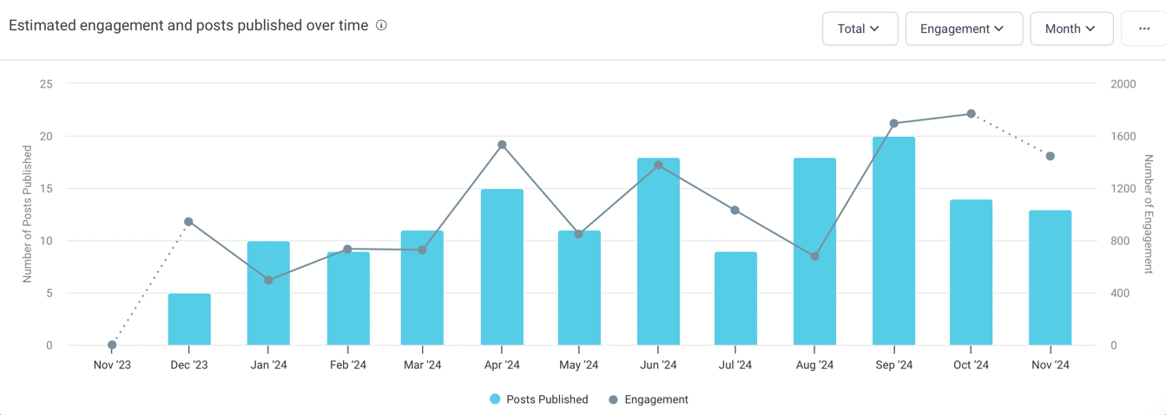

***Figure 4.2.2.6:*** *Asistence’s Facebook engagement and posts published over time. (BuzzSumo, n.d.).*

As displayed on Figure *4.2.2.6*, Asistence’s engagement has been unsteady over the months. Lately they have been posting more short videos, which has increased their audience’s engagement – resulting in more likes and comments per post (BuzzSumo, n.d.). Knowing this, the team has recommended ICP the use of short reels on their platforms.

The team was only able to meet with the co-director of MigAct. The outline of the interview that was conducted by the team can be found on Appendix A. Said interview revealed that they do not focus that much on social media, but they rather choose to spread the word by doing in-person events. They have different target audiences, such as the general public, migrants or even other NGOs, and they divide into age groups. MigAct only uses Instagram, Facebook and LinkedIn because they consider that the message is better portrayed by limiting it to fewer platforms. Each platform is dedicated to different types of content – for example, LinkedIn is more formal while Instagram is used to promote events in a more dynamic way – which makes it hard to know which one is most effective. They do not use social media for fundraising, instead they just want to be known and for people to see the work that they do. The organization also prefers to engage with the public in person rather than through social media. The challenges MigAct faces when trying to maintain an active social media presence have to do with personnel or resources shortages, they just have one person monitoring their social media platforms. As the team previously mentioned, this organization prefers to use what they called “Snowball effect”, meaning they would rather spread the word of what they do personally. They also mentioned that they have policies for when they must confront negative feedback or any issues during their events, but they haven’t had any major encounter for the moment.

In conclusion, the quantitative analysis of other NGOs and the responses from the interview – which gave the team the knowledge of how other organizations try to communicate to the public – helped our team with creating a new and better communication strategy plan for ICP.

# 5.0 Deliverables

With these mentioned findings, the team has compiled two different plans: a new funding and communication strategies plan. These two plans include recommendations the team believes would result in Integrační Centrum Praha finding less restrictive sources of funding and more success in its media practices. In this section, the team will provide a brief overview of these recommendations – a more detailed outline of this new funding and communication strategies plan can be found in *Supplementary Materials A: New Funding Strategies Plan* and *Supplementary Materials B: New Communication Strategies Plan*, respectively.

The team first composed a new funding strategies plan. Our team recommends various international funds, such as the Visegrad fund, Nadace Čez, EPIM, and Nadace OSF, that ICP should apply to. Additionally, various corporations in the accommodation and food services, manufacturing, and construction industries were recommended for ICP to reach out to along with other networking advice and courses to help ICP get a partnership with a company. Crowdfunding is also explored as a viable option for ICP to use to secure alternative funding sources. A plan is outlined for how ICP should go about establishing a presence on various crowdfunding sites.Two sites were suggested: Darujme.cz and Why Donate. Recommendations outlined various funding campaigns that ICP could create through these platforms. Lastly, the team also displayed detaileddesign recommendations for how to use color, positioning, and wording to design a donate button that increases clickthrough. Then, a donation page that leverages donation tiers, reoccurring donations, and website design to maximize donations. Further strategies to advertise their donation page through their social media, newsletters, and events were outlined for ICP to follow in order to produce optimal results.

The team then composed a new communication strategies plan. Initially, the team focused on the organization’s social media platforms. Specifically, the team focused on three social media platforms: Instagram, Facebook, and YouTube. The team analyzed other Czech NGOs and identified several improvements that ICP could implement to their own platforms. For Instagram, ICP should resort to short-form and more entertaining content. On the other hand, ICP should post more educational and utilize the story-telling method on Facebook. Lastly, ICP should reduce the length of its YouTube content and make it more engaging. Nonetheless, ICP would benefit from creating collaborative content with both influencers and other Czech organizations to pull from two different audiences. Lastly, the team also made recommendations to lessen the stress on the head of PR and her partner to generate content. Then, the team also analyzed the organization’s more traditional media platforms. Here, the team focused on three different formats: newsletters, flyers, and surveys. Specifically, the team proposed recommendations relative to each format that would maximize the effectiveness of their efforts. For newsletters, it is important that ICP composes concise, visually appealing editions and sticks to a strict schedule. In other terms, it is important that the content within the newsletter is short and includes images and infographics. On the other hand, it is important that the flyers are made with attention-grabbing headlines and are mass distributed across Prague. Likewise, these said flyers should also include surveys. The team composed an outline for a survey that ICP should refine and implement. This way, the organization can receive both quantitative and qualitative data on its intended audience. Combined, the team believes that ICP can reach a much broader audience and ensure success in their potential new funding strategies.

# 6.0 Conclusions

The following sections consist of final reflections upon the completion of the team’s project. Specifically, it includes ethical considerations and reassurances about the methods followed to complete this project. In addition, it also includes limitations on how the project itself was conducted. Lastly, it includes a concise summary of the team’s recommendations and findings.

# 6.1 Ethical Considerations

The team has abided by IRB guidelines, and no personal data not explicitly agreed to will be divulged when publishing this paper. In addition, ICP has agreed to use its internal data to create these recommendations. The team has ensured that the data given by ICP and gathered through research, interviews, and surveys is securely protected and confidential. Furthermore, the team avoided any bias within their recommendations to ICP, ensuring they were made in ICP’s interest and supported by ICP’s mission statement. The team aims to contribute to ICP’s success and growth while adhering to the highest ethical standards.

# 6.2 Limitations

Since the team’s project has developed significantly since its inception, the team was limited in certain areas. For instance, ICP asked the team to survey individuals across Prague in our fifth week of being on-site; however, we were unable to do so due to its timing and lack of IRB approval. As a result, the team was not able to collect the amount of data regarding ICP’s audience as desired. Nonetheless, the team formed a survey and composed flyers that ICP can distribute to collect both quantitative and qualitative data. In addition, the team struggled to gain first-party insights into other Czech NGOs. Specifically, the team was only able to secure two out of seven interviews, limiting the ability to collect in-depth data. Instead, the team relied on third-party analysis. In all, the team believes the project was successful despite the depicted limitations.

# 6.3 Final Reflections

The goal of this project was to find less restrictive funding strategies for Integrační Centrum Praha to ensure the organization's ability to improve its operations in the Czech Republic while also recommending communication strategy improvements. Through thorough research, a qualitative structured interview, and an analysis of ICP’s as well as other Czech NGO’s media platforms, the team was able to identify relevant strategies for the organization to pursue. By implementing the team’s new funding and communications strategy plan, the organization will benefit from less restrictive sources of funding that can be allocated towards organizational improvements to ensure ICP’s continued success.

# Bibliography

ADRA. (n.d.). *We help people in need*. Adra.cz. <https://adra.cz/en/>

Asylum Migration Integration Fund (AMIF). (2023, May 15). *Funding regulations*. Asyl-, Migrations- Und Integrationsfonds. [www.eu-migrationsfonds.de/EN/Foerderung/Foerderbestimmungen/foerderbestimmungen_node.html](http://www.eu-migrationsfonds.de/EN/Foerderung/Foerderbestimmungen/foerderbestimmungen_node.html)

Bromley, P., Schofer, E., Longhofer, W. (2020, September). *Contentions over world culture: The rise of legal restrictions on foreign funding to NGOs.* Social Forces, Volume 99, Issue 1, Pages 281–304. <https://doi.org/10.1093/sf/soz138>

Brozova, K., Jureckova, A., & Pacovská, A. (2018). *The wages of fear: attitudes towards refugees and migrants in Czech Republic. Warsaw*. Institute of Public Affairs. <https://www.britishcouncil.pl/sites/default/files/czech_pop_0.pdf>

Brüker, H. (2022) *War in the Ukraine: consequences for the governance of refugee migration and integration*. Econstor. <https://www.econstor.eu/bitstream/10419/263864/1/CESifo-Forum-2022-04-p41-48.pdf>

Busk, S. (2022, August 22). *How to create and publish your first newsletter*. Maxprog’s Blog (How to use Maxprog products). <https://www.maxprog.com/site/blog/post.php?id=69>

BuzzSumo. (n.d.). *Media mentions in minutes. content ideas for days*. BuzzSumo.com. <https://buzzsumo.com/>

Canva. (2024). *The Ultimate Guide to Flyer Design*. <https://www.canva.com/learn/the-ultimate-guide-to-flyer-design/>

Centrum Locika. (n.d.). *Support us*. Centrumlocika.cz. <https://www.centrumlocika.cz/>

Čtk, R. (2018, December 10). *Czech human rights commissioner: human rights not considered important enough, critique of nonprofits is problematic*. Romea.cz. <https://romea.cz/en/czech-republic/czech-human-rights-commissioner-human-rights-not-considered-important-enough-critique-of-nonprofits-is-problematic>

ČTK. (2021). *New data reveals which industries in the Czech Republic employ the most foreigners*. Expatscz. <https://www.expats.cz/czech-news/article/new-data-reveals-the-number-of-foreign-workers-in-the-czech-republic>

Czech Statistal Office. (June 10, 2024). *Net migration, immigration, and emigration in Czechia from 1995 to 2023*. Statista. <https://www.statista.com/statistics/1232825/change-of-population-by-migration-in-czechia/>

Darujme.cz (n.d.). *Darujme.cz*. Darjume.cz. <https://www.darujme.cz/?lang=en>

Dimitrov, A., & Pavlov, V. (2023, December 26). *Economic challenges to Ukranian refugee integration in central and eastern Europe*. Journal of Liberty and International Affairs (Bitola), 9(3), 98–118. <https://doi.org/10.47305/JLIA2393089d>

Dodevska, I. (2021, November 19). *What kind of society is the Czech Republic for immigrants?* MigrationOnline.cz. <https://migrationonline.cz/en/e-library/what-kind-of-society-is-the-czech-republic-for-immigrants>

Drbohlav, D. (2003). *Immigration and the Czech Republic (with a special focus on the foreign labor force)*. The International Migration Review, 37(1), 194–224. <http://www.jstor.org/stable/30037823>

Duong, H. T. (2017). Fourth Generation NGOs: Communication Strategies in Social Campaigning and Resource Mobilization. Journal of Nonprofit & Public Sector Marketing, 29(2), 119–147. <https://doi.org/10.1080/10495142.2017.1293583>

European Programme for Integration and Migration (EPIM). (2023, May 26). *EPIM*. Epim.info. <https://epim.info/>

European Commission. (2024, October 24) *Asylum, migration and integration fund (2021-2027)*. Home-Affairs.ec.europa.eu <https://home-affairs.ec.europa.eu/funding/asylum-migration-and-integration-funds/asylum-migration-and-integration-fund-2021-2027_en>

European Commission. (2021). *Cohesion policy*. Inforegio - Cohesion policy. <https://ec.europa.eu/regional_policy/policy/what/investment-policy_en>

European Commission. (2024). *Migration management: welcoming refugees from Ukraine*. Migration and Home Affairs. <https://home-affairs.ec.europa.eu/policies/migration-and-asylum/migration-management/migration-management-welcoming-refugees-ukraine_en>

European Programme for Integration and Migration (EPIM). (2023, May 26). *Epim*. Epim.info. <https://epim.info/>

Forrest. (2024). *Nadace ČEZ*. Grant Programs. <https://www.nadacecez.cz/>

Foundation Source. (2023, March 17). *What is a private foundation?* Foundation Source.com. <https://foundationsource.com/what-is-a-private-foundation/>

Frank, L., Procházka, J., & Stojar, R. (2018, November). *International migration and the Czech Republic: assumptions and reality*. International Business Information Management Association. <https://www-engineeringvillage-com.ezpv7-web-p-u01.wpi.edu/app/doc/?docid=cpx_M61e14263169dfbedfb1M7c7710178163167&pageSize=25&index=1&searchId=d609f9886c0449268de47496e9b376cb&resultsCount=36&usageZone=resultslist&usageOrigin=searchresults&searchType=Quick>

González‐Leonardo, M., Neville, R., Gil‐Clavel, S., & Rowe, F. (2024, May 9). *Where have Ukrainian refugees gone? Identifying potential settlement areas across European regions integrating digital and traditional geographic data*. Population Space and Place. <https://doi.org/10.1002/psp.2790>

Greengard, S. (2024, November 5). C*rowdsourcing*. Britannica Money. <https://www.britannica.com/money/crowdsourcing>

Hora, N. (2019). *What are the biggest industries in the Czech Republic?* WorldAtlas. <https://www.worldatlas.com/articles/what-are-the-biggest-industries-in-the-czech-republic.html>

Huntsberger, A. (2023, December 11). *8 donate button best practices for nonprofits*. Neon One. <https://neonone.com/resources/blog/donate-button/>

InBáze.(2024, March 21). *Aktuality.* Inbaze.cz. [inbaze.cz/](https://inbaze.cz/)

Integrační Centrum Praha [@icpraha]. (2024, September 25). *Language Classes*. Instagram Post. <https://www.instagram.com/p/DAWJb2RKC2W/?img_index=1>

Kroky Dobra. (n.d.). *Charitable organization – kroky dobra*. Krokydobra.cz. <https://www.krokydobra.cz/en>

Ladd, A. D. (2010, December). *Developing effective marketing materials: promotional posters and flyer design considerations*. UTIA Tennessee. <https://utia.tennessee.edu/cpa/wp-content/uploads/sites/106/2020/10/cpa180.pdf>

Ministry of Foreign Affairs of the Czech Republic. (n.d.) *International Visegrad Fund*. Mzv.gov.cz. [mzv.gov.cz/jnp/en/foreign_relations/visegrad_group/international_visegrad_fund_1.html](https://mzv.gov.cz/jnp/en/foreign_relations/visegrad_group/international_visegrad_fund_1.html)

Mazhak, I., Paludo, A. C., & Sudyn, D. (2024). *Self-reported health and coping strategies of Ukrainian female refugees in the Czech Republic*. European Societies, 26(2), 411-437. <https://www.tandfonline.com/doi/full/10.1080/14616696.2023.2203230>

McAuliffe, M., & Oucho, L. A. (2024). *World migration report 2024*. Worldmigrationreport.iom.int <https://worldmigrationreport.iom.int/msite/wmr-2024-interactive/#:~:text=The%20current%20global%20estimate%20is,percent%20of%20the%20global%20population>.

McRay, G. (2024, May 28). *Top 5 reasons why nonprofits fail*. Foundation Group Blog. Newstex. <https://www.501c3.org/top-5-reasons-why-nonprofits-fail/>

Nadace OSF. (2019, November 5). *Granty*.Osf.cz. <https://osf.cz/granty/>

Nadace Via. (2020). *The community in which we live*. Nadacevia.cz. <https://www.nadacevia.cz/>

Organization for Economic Cooperation and Development (OECD). (2023). *OECD economic surveys: Czech Republic.* Czech Republic. <https://www.oecd.org/en/topics/sub-issues/economic-surveys/czechia-economic-snapshot.html>

Organizace Pro Pomok Uprchlikum (OPU). (2024, March 1). *Organizace Pro Pomok Uprchlikum*. Opu.cz. <https://www.opu.cz/en/>

Pace University (2024, June 27). *Communications best practices for social media*. Pace University Online. <https://online.pace.edu/articles/communications/communications-best-practices-social-media/>

Potluka, O., Spacek, M., & von Schnurbein, G. (2017, March 8). *Impact of the EU structural funds on financial capacities of non-governmental organizations*. Voluntas (Manchester, England), 28(5), 2200–2223. <https://doi.org/10.1007/s11266-017-9845-1>

Prague City Hall. (n.d.) *Prague for all: integration centre prague*. Metropolevsech.eu. <https://metropolevsech.eu/en/kontakty/integracni-centrum-praha/>

Richter, J. (2014, March 12). *Czech Republic leads region with crowdsourcing but full potential still to be tapped*. Radio Prague International. <https://english.radio.cz/czech-republic-leads-region-crowdsourcing-full-potential-still-be-tapped-8275948>

Sampougkasidis, A. (2024, May 2). *Creating a donation-page design-prototype for a non-governmental organization – a participatory action research*. Theseus.fi. <http://www.theseus.fi/handle/10024/855637>

Social Blade. (n.d.). *Youtube, twitch, twitter, & instagram statistics*. Socialblade.com. <https://socialblade.com/>

Survey Monkey. (2024). *Writing great survey questions: Expert tips and templates*. SurveyMonkey. <https://www.surveymonkey.com/mp/writing-survey-questions/>

Svidroňová, M. M., Vaceková, G., Plaček, M., Matulová, M., Hrůzová, L., & Harringová, L. (2020, June 7). *Alternative non-governmental funding methods: crowdfunding in the Czech Republic and Slovakia*. Applied Economics Letters, 28(9), 748–754. <https://doi.org/10.1080/13504851.2020.1776828>

UNHCR. (July 29, 2024). *Estimated number of refugees from Ukraine recorded in Europe and Asia since February 2022 as of July 2024, by selected country*. Statista. <https://www.statista.com/statistics/1312584/ukrainian-refugees-by-country/>

UNHCR. (n.d.) *Czech Republic*. Unhcr.org. <https://www.unhcr.org/us/countries/czech-republic>

Vláda České Republiky (2022, June 27). *Main areas of state subsidy policy towards non-state non-governmentals organizations to support the public beneficial activities for 2023*. <https://vlada.gov.cz/cz/ppov/rnno/aktuality/hlavni-oblasti-statni-dotacni-politiky-vuci-nestatnim-neziskovym-organizacim-na-podporu-verejne-prospesnych-cinnosti-pro-rok-2023-197441>

Ward, A., Ray, K., Fakhoury, A. (2021, May 6). *Caution: An influx of federal funds comes with increased risks for organizations.* Our Insights. <https://www.plantemoran.com/explore-our-thinking/insight/2021/05/an-influx-of-federal-funds-comes-with-increased-risks-for-nonprofits>

WhyDonate. (2024, October 24). *Create Your Own Donation Website*. <https://whydonate.com/en/donate-button-website/>

Ziliani, C., Ieva, M., Gázquez-Abad, J. C., & D’Attoma, I. (2022, January). *I read, therefore I buy? Analyzing the impact of flyer distribution and readership on purchase behaviour*. Science Direct. <https://doi.org/10.1016/j.jretconser.2021.102725>

Zogata-Kusz, A. (2022). *Policy advocacy and NGOs assisting immigrants: Legitimacy, accountability and the perceived attitude of the majority*. Social Sciences, 11(2), 77. <https://www.mdpi.com/2076-0760/11/2/77>

# Appendices

**Appendix A: Qualitative Structured Interviews**

*[First ask for consent]*

Provide interviewee with IRB consent form and wait for the form to be signed.

*[Questions]*

1. Who is the primary audience the organization aims to reach through its communication strategies? Are there second audiences the organization hopes to reach?
2. What social media platforms has the organization found to be most effective for reaching the target audience?
3. Are there unique strategies in place for each distinct platform, or is there a more unified approach?
4. What type of content resonates more with the organization’s audience?
5. How is this content managed? Who oversees content creation and platform management? Is there a dedicated team for these different aspects?
6. How would you describe the organization’s level of interaction with its followers online? Have you noticed increases in engagement when your team interacts more directly with them (i.e. replying to comments)?
7. What tools does the organization utilize to analyze the effects of communication across social media platforms?
8. Could you share examples of some posts that performed better than others?
9. What are the biggest challenges the organization faces in maintaining an active social media presence? Are there any barriers that prevent you from growing?
10. Outside of social media, how does the organization interact with more traditional sources of media (i.e. newspapers)?
11. What strategies have been the most effective for gaining engagement across these more traditional sources of media?
12. Does the organization have protocols set in place for handling negative feedback?
13. Are there any long-term strategies already set in place for the organization to grow its community outreach?
14. What tools does the organization currently use to evaluate and improve its communication strategies?
15. Has the organization received any feedback directly from its followers on how to improve its communication strategies?

*[Appreciation]*

Thank you for taking the time to be a part of this interview.

**Appendix B: Email Prompt for Other Czech NPOs**

Dobrý den,

The team are a group of students from Worcester Polytechnic Institute – a university located in Massachusetts, U.S.A – who are currently doing a research-based paper on migrant-based non-profit organizations in the city of Prague, Czech Republic. The team are currently working with Integrační Centrum Praha (ICP) and the team plan to be in Prague until 14/12/2024.

The team's research involves looking into local migrant-based non-profit organizations’ communication strategies – this involves analyzing their use of their website, social media platforms, and advertising elements. These findings will help understand what improvements a similar NPO can implement for the success of its own mission.

After doing research into other similar organizations, the team came across your organization and believe that your mission aligns with what the team are looking for. Would you be willing to work with us and set up a time to be a part of an interview with us?

Děkuji vám,

Interactive Qualifying Project Team

Worcester Polytechnic Institute

**Appendix C: How to Apply to Visegrad Fund**

*[Visegrad Fund]*

1. Register in the ‘MyVisegrad’ System: Begin by creating an account in the ‘MyVisegrad’ system.
2. Submit Your Project Idea: Provide details about your project by answering questions such as:
   1. "What organization do you represent?"
   2. "Who are your partners?"
   3. "What do you plan to do with your partners?"
   4. "How many participants do you plan to involve?"
   5. "What is the age range of the participants?"
3. Wait for Approval: Once your project idea is reviewed and accepted by the Fund, you will receive a notification that the application form is open.
4. Complete the Application Form: Proceed to fill out the required details in the application form and submit it in the online system” (Ministry , n.d.).

**Appendix D: How to Apply to Nadace ČEZ**

*[Nadace ČEZ]*

1. Create an account at [www.zadost.online](https://www.zadost.online).
2. Start the application process for one or multiple grants.
3. Supply Nadace ČEZ with various documents that prove legitimacy.
4. Provide clear reporting of fund usage and transparency with the public (Forrest, 2024).

**Supplemental Materials**

**Supplemental Material A: New Funding Strategies Plan**

# New Funding Plan

By performing thorough research, the team has composed a new funding strategies plan. For more information on the research conducted to produce these recommendations, please see section 4.0 Results. Listed below are recommendations the team believes ICP should approach to find less restrictive sources of funding:

**Within Private Sector:**

1. International Funds
   1. Visegrad Fund (V4 Gen Grants) - <https://www.visegradfund.org/>
      1. This fund can be applied to by ICP if you are participating in a project with another organization that resides in a different V4 country (Czech Republic, Poland, Hungary, Slovakia). For more information on the application process, see Appendix C.
      2. This is a project-based grant, though 15% of the funds can be used for operational costs incurred during the project timeline.
   2. Nadace ČEZ (Support for Regions Grant and the Non-Profits - Professional Development of Social Care Grant) - <https://www.nadacecez.cz/>
      1. The Non-Profits - Professional Development of Social Care Grant opens applications on January 27, 2024.
      2. The Support for Regions Grant has applications open year-round. For more information on the application process, please see Appendix D.
      3. These programs can entirely go towards funding an organization’s operational and logistical costs.
   3. Nadace OSF (No Currently Running Grants) - <https://osf.cz/>
      1. This grant runs one-time, non-reoccurring grants and projects that NGOs can apply for. Past projects have been relevant to ICP.
      2. Allow a portion or all of funds to be allocated to organizational costs.
   4. European Philanthropic Initiative for Migration (EPIM) (No Currently Running Grants) - <https://epim.info/>
      1. This grant runs one-time, non-reoccurring grants and projects that NGOs can apply for. Past projects have been relevant to ICP.
      2. Allow a portion or all of funds to be allocated to organizational costs.
2. Corporate Partnerships
   1. SAP Services
      1. Their workforce is 60% foreigners, and it continues to grow every year.
   2. Accommodation and Food Services Industry
      1. Lokál: Operate 5 locations within Prague. Serve traditional Czech Cuisine
      2. Kolkovna: Operates 14 restaurant locations across Prague, with subsidiary restaurants such as Aroma and Break Time Bistro
      3. Pilsner Urquell Original Restaurants: With dozens of locations across Prague, they serve traditional Czech cuisine and beer
      4. Czech Inn Hotels: 24 locations across Prague
      5. Orea Hotels & Resorts: 3 Locations across Prague and 14 others across Brno and the rest of the Czech Republic
   3. Construction
      1. Metrostav: Largest Czech construction company
      2. Skanska Czech Republic and Slovakia: One of the world's largest property development and construction companies. Operates in the Czech Republic
      3. STRABAG: Leading construction companies in the Czech Republic
   4. Manufacturing
      1. Škoda Auto: Czech car manufacturer
      2. Hyundai Motor Manufacturing Czech: Multiple factories within Czechia
      3. TPCA (Toyota Peugeot Citroën Automobile Czech): Multiple manufacturing plants within the Czech Republic
      4. Foxconn CZ: Electrical manufacturer with two locations within Czechia
   5. Potential solutions to failing corporate partnerships
      1. Nadace Via - <https://www.nadacevia.cz/>
         1. Nadace Via’s Community Academy offers free classes for individuals within non-profits to enhance networking and connect with a support network of like-minded professionals at various non-profits and organizations
         2. Nadace Via’s The Community in Which We Live program offers funds for projects. But, more importantly, it provides 5 hours of networking and learning seminars for each approved project.
      2. General Awareness
3. Through following the communication strategy plan our team has also provided, awareness of ICP will build trust and could allow ICP to get past the talking stages
   * 1. Leverage Success Stories
        1. If one partnership does come to fruition, collecting quantitative and qualitative data to track the effectiveness of previous partnerships. This allows you to have data to show other potential partners.
        2. Testimonials from successful campaigns will help build trust with company’s and help break through the talking stages
     2. Host Networking Events
4. By hosting career fairs for your migrant clientele, relationships can be built with companies, fostering potential future cooperation.

**Within Crowdfunding**

In terms of crowdfunding, the team recommends that ICP first utilizes Darujme.cz to gauge how successful they are at receiving funds in this manner. This is because Darujme.cz is more catered to NGOs that are in need of alternative funding methods. Since there are no transactional fees, even if the funds that are collected are minimal, it will all come back to ICP. There is also the additional benefit that Nadance Via will match the funds that they make, up to about 910 USD. If it is seen that ICP is successful in its crowdfunding campaign, it should then look to expand to WhyDonate, as it would reach a larger audience and ensure continued crowdfunding success.

1. Darujme.cz
   1. Since Darujme.cz has a more project-based approach, recommendations can be made on how to present their campaign.
      1. The team recommends the following:
         1. Asking for help on various specific programs. Ex:
            1. Help us develop our Czech Language courses! [insert the specifics tied to why funds are needed]
            2. Help us maintain legal counseling! [insert the specifics tied to why funds are needed]
         2. Help us maintain structural organization. We want to use these funds to find IT help!

**Within General Public:**

To secure funding from donors directly through ICP’s website, ICP needs to develop a strong individual donor base through improving its communication strategy, which will be explained more in the communication strategy plan. Though, a well-designed donate button and donation page on your website will increase donation amounts and provide a consistent stream of income that does not have usage restrictions.

1. Donation Button
   1. A well-designed donation button is key to driving visitors to your website to donate.
      1. The location of the donate button is very important. To always keep it visible while navigating the page, our team recommends it be added to the top menu bar of the page.
      2. The color of the donate button is extremely important. The color must contrast with that of the background (currently white). Additionally, the exact color can provoke feelings in donors, making them more or less likely to click it. Our team recommends that ICP use green, as it has a good connotation while matching the color of ICP and its branding. Though, our team know that ICP is trying to rebrand their site soon, so additional suggestions and cautions are listed below:
         1. Green is often associated with sustainability, health, growth, balance, and wealth.
         2. Blue conveys dependability, trust, calmness, professionalism, and security.
         3. Red invokes urgency, passion, action, and danger, but also may signal potential donors to ‘stop’ and lead to a decrease if not careful.
      3. The phrase on the donate button is very important. Using a “Call to Action,” or a phrase that prompts the donor to complete a certain action. This often takes the form of phrasing and directly telling an individual to donate. Some examples include:
         1. “Donate Now”
         2. “Support Us”
         3. "Make a Difference"
         4. "Support Our Mission"
         5. “Help a Migrant”
2. Donation Page
   1. Once donors have clicked the donate button or arrived through a method discussed next, a well-designed donation page is proven to increase donations.
      1. Donation tiers, or predetermined options of different values that donors can click (e.g., 250 CZK, 500 CZK, 1000 CZK), have been proven to increase donations. It does this in two ways:
         1. Having predetermined values reduces friction and can cause the user to think less when donating by selecting a predetermined option, making them more likely to complete the process.
         2. Users may be prompted to donate higher amounts if the upper range of the donation tier is quite high. You don't really expect people to donate at the highest tier, but it can cause them to increase their donation.
      2. Reoccurring donations should be included as an option as well. Tiers for these donations should be used as well, though less than one-time donations. It can sometimes be easier to get a donor to donate 100 CZK a month rather than 500 CZK at once. Additionally, this method provides reoccurring and consistent income for ICP.
      3. Labeling donation tiers is also effective. For example, let's say the cost to run one language course was ~500 CZK; labeling the 500 CZK tier as “pays for a language course for X migrants” will cause an emotional connection with the donor and build trust. Some other ideas include:
         1. For one cup of coffee a month, you can help a migrant have a brighter future in their new home.
         2. Cover the educational materials and support for a migrant child.
         3. Fund a full day of legal counseling, empowering migrants to navigate complex legal systems and secure their place in our community.
         4. Provide X migrants with a socio-cultural course, teaching them Czech traditions and systems, paving their way for success.
      4. Reducing friction, or making the donation as easy as possible, greatly increases donations. Even the difference of one extra clicks the donor must perform before completing the donation decreases the chance of completing the donation.
      5. Building trust throughout your donation page and website is key. Imagery and real stories are the best way to do this. For example:
         1. Migrant testimonials
         2. Pictures and videos of projects and events. Show your work in action
         3. A blurb on what donations are used for in the organization
         4. Share funding/spending reports publicly to increase transparency
      6. Lastly, being appreciative is important in securing repeat donors. A simple thank you screen that lets them know they are making a difference displayed after a completed donation makes donors more likely to donate again.
3. Donation Advertising
   1. Our team recommends including a link to your donation page in as many communication outreaches (social media post captions, social media profile bios, newsletters, QR codes at events, QR codes on flyers) as possible.
      1. If contact information of past clients is known, reaching out via call, text, or email could cause them to donate. Framing this as giving back to an organization that has done so much for them will make it more likely for them to want to give back.

**Supplemental Material B: New Communication Strategies Plan**

Through conducting qualitative structured interviews and media platform analysis, the team has composed a new communication strategy plan. Listed below are recommendations the team believe ICP should approach to ensure reach a broader audience and maximize the benefits of the funding strategies suggested:

**Social Media Platforms:**

1. Type of Content:
   1. Instagram:
      1. Posts should be simple, concise, and more informal.
      2. Utilize the buttons on story posts to increase engagement:
         1. Short Q&A Button.
         2. Poll Button.
         3. Add Yours Button.
         4. Donation Button.
         5. Countdown Button.
   2. Facebook:
      1. Posts should be educational and utilize the storytelling method.
      2. Use examples of events ICP does.
      3. Limit the number of posts per day to once.
   3. YouTube:
      1. Posts should be short, educational and appealing.
2. Collaborations:
   1. With influencers:
      1. Numbers show that when participating with famous people, posts get more likes and more engagement. By collaborating with influencers ICP can reach a larger audience.
   2. With other organizations:
      1. Partnering with other corporations can be beneficial for both ends, so this can be a good way of reaching other types of audiences. With this help, more people can participate in ensuring ICP’s success.
3. New ideas:
   1. Since the person in charge of creating new content cannot be in more than one place at the same time, people at ICP’s events can take photos and videos and upload them tagging ICP or even just sending them so they can be uploaded to ICP’s platforms.
   2. A type of video that catches people’s attention these days is doing “a day in the life of...”. In these videos you can show a compilation of short videos showing what a day at an ICP event looks like and later add an audio with voice in off explaining what you are doing. This is a good method to show people what ICP does in a more entertaining way.

**Traditional Media Platforms:**

1. Newsletters:
   1. Initially, ICP should focus on **newsletters –** the team believes that it is the most effective form of traditional communication, as it is often cheap and accessible. Below are certain recommendations specific to newsletters to help ensure that they are most effective (Busk, 2022):
      1. Limit the number of times a newsletter is emailed out to one a month.
      2. Stick to a certain schedule – i.e. the first Monday of each month.
      3. Create concise and visually appealing newsletters – include images.
      4. Tell success stories of those individuals that ICP currently helps or has helped in the past.
2. Flyers:
   1. ICP should simultaneously give out and publish **flyers** around the city of Prague. This would help spread ICP’s brand and mission to a much broader audience. Below are other recommendations specific to flyers, as well as two examples:
      1. Recommendations for flyer design (Canva, 2024):
         1. Attention-grabbing headline, it needs to stand out.
         2. Balance. Don’t add too much information, things need to be balanced, well-spaced, and uncrowded.
         3. Use the right typography. The right fonts can help drive home your branding and reinforce your messaging.
         4. Focus on one key message. The less you try to communicate, the easier your message will be to get across.
         5. Design with your audience in mind. If you want your flyer design to be successful, you need to think about who you’re designing it for.
      2. Example flyers:
         1. [Example Flyer One](https://ibb.co/9vmhm4p)
         2. [Example Flyer Two](https://ibb.co/LP7SxFG)
         3. [Example Flyer Two (in Czech)](https://ibb.co/NgvrzRj)
   2. There are several options for places in which ICP can place their flyers for free and without the need for permits. Here are a few suggested places:
      * 1. Gymnasiums
        2. Coffee Shops
        3. Restaurants
        4. Public Libraries
        5. Parks with Designated Bulletin boards
        6. Co-working Spaces
3. Surveys:
   1. ICP should also pursue quantitative and qualitative data through the use of **surveys**. Below are suggestions on what makes a survey successful as well as an example survey:
      1. Recommendations for surveys (Survey Monkey, 2024):
         1. Closed-ended questions. They generate quantitative data that can be used to measure variables.
         2. Ensure your survey questions are neutral. Putting an opinion in your question prompt can damage your survey data by influencing respondents.
         3. Keep a balanced set of answer choices. Respondents need a way to provide honest and thoughtful feedback.
         4. Don’t ask for two things at once. A common culprit in causing confusion is the double-barreled question. It asks respondents to assess two different things at the same time.
      2. Example survey:
         1. <https://wpi.qualtrics.com/jfe/form/SV_29x8MOcdsOpKG1M>